MICROSERVICE ARCHITECTURE

A PRACTICAL REPORT

ON

MICROSERVICES ARCHITECTURE

SUBMITTED BY  
Mr.**[PRASAD PRASHANT JAGDISH]**

Roll No: **[IT21013]**

UNDER THE GUIDANCE OF

PROF. MEHDI REZAEI

Submitted in fulfillment of the requirements for qualifying

MSc. IT Part I Semester - II Examination 2021-2022

University of Mumbai

Department of Information Technology

R.D. & S.H National College of Arts, Commerce & W.A. Science College Bandra (West), Mumbai – 400 050

 

R. D.& S.H National & W. A. Science College

**Bandra (W), Mumbai – 400050*.***

**Department of Information Technology**

**M.Sc. (IT)**

**Certificate**

*This is to certify that* ***Microservice Architecture*** *performed at* ***R. D & S.H National & W.A. Science College*** *by* ***Mr.PRASAD PRASHANT JAGDISH*** *holding Seat No.* ***IT21013*** *studying Master of Science in Information Technology Semester – II has been satisfactorily completed as prescribed by the University of Mumbai, during the year 2021 – 2022.*

|  |  |  |
| --- | --- | --- |
| **Lecturer In charge** | **External Examiner** | **Head of Department** |

**College Stamp**

|  |  |  |  |  |
| --- | --- | --- | --- | --- |
| **Sr. No** | **Date** | **Practical** | **Page No.** | **Sign** |
| 1 |  | Building APT.NET Core MVC Application |  |  |
| 2 |  | Building ASP.NET Core REST API. |  |  |
| 3 |  | Working with Docker, Docker Commands, Docker Images and Containers |  |  |
| 4 |  | Installing software packages on Docker, Working with Docker Volumes and Networks. |  |  |
| 5 |  | Working with Circle CI for continuous integration. |  |  |
| 6 |  | Creating Microservice with ASP.NET Core. |  |  |
| 7 |  | Creating Backing Service with ASP.NET Core. |  |  |
| 8 |  | Presentation / Case Studies |  |  |

**INDEX**

**Practical No. 1**

**Aim: -** Building APT.NET Core MVC Application

**Code Implementation: - (Include steps)**

1)Install .Net Core Sdk (Link: https://dotnet.microsoft.com/learn/dotnet/hello-world-tutorial/install)

2)create folder MyMVC folder in D: drive or any other drive

3)open command prompt and perform following operations

**Command: to create mvc project dotnet new mvc --auth none**

4) **Go to controllers folder and modify HomeController.cs file to match following:**

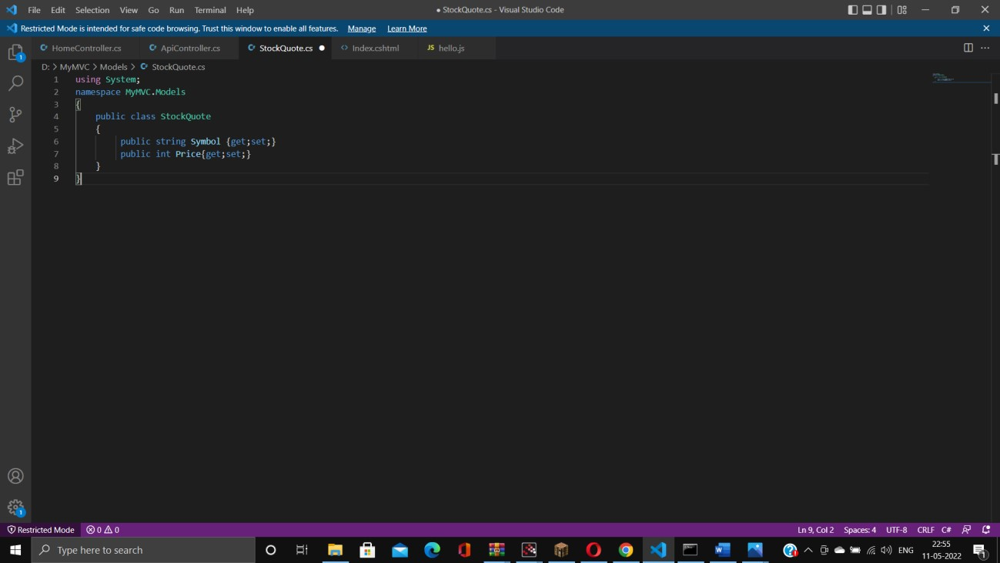

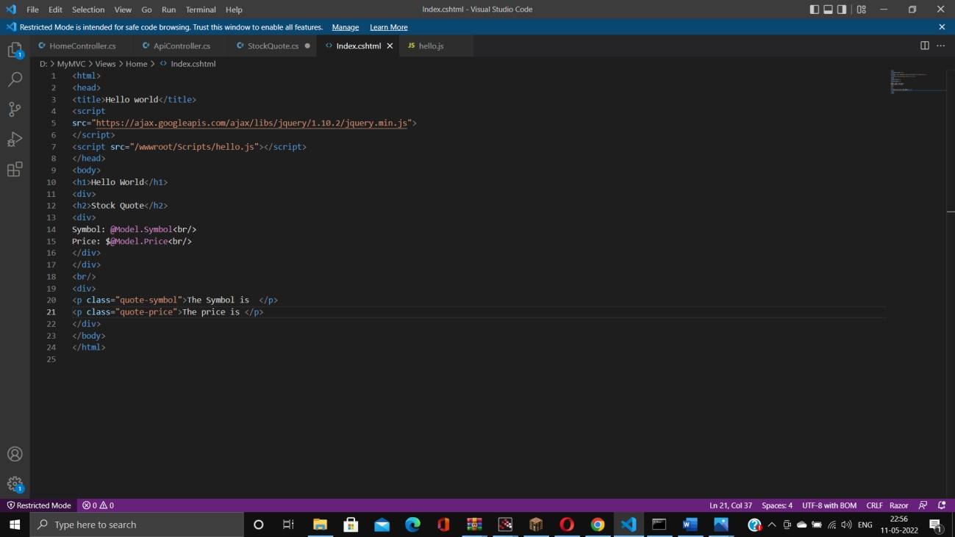

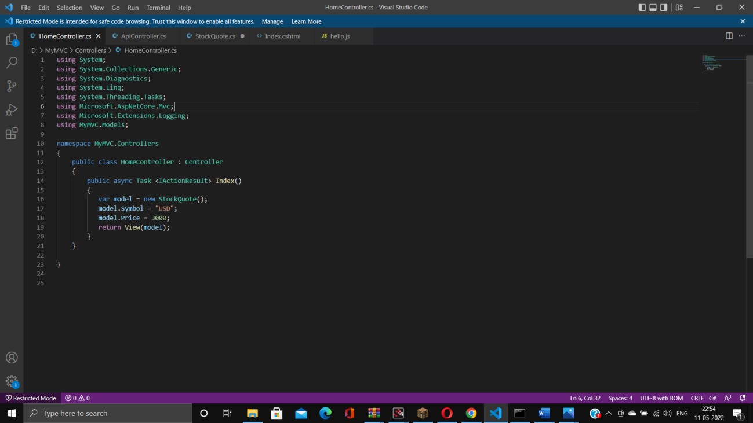

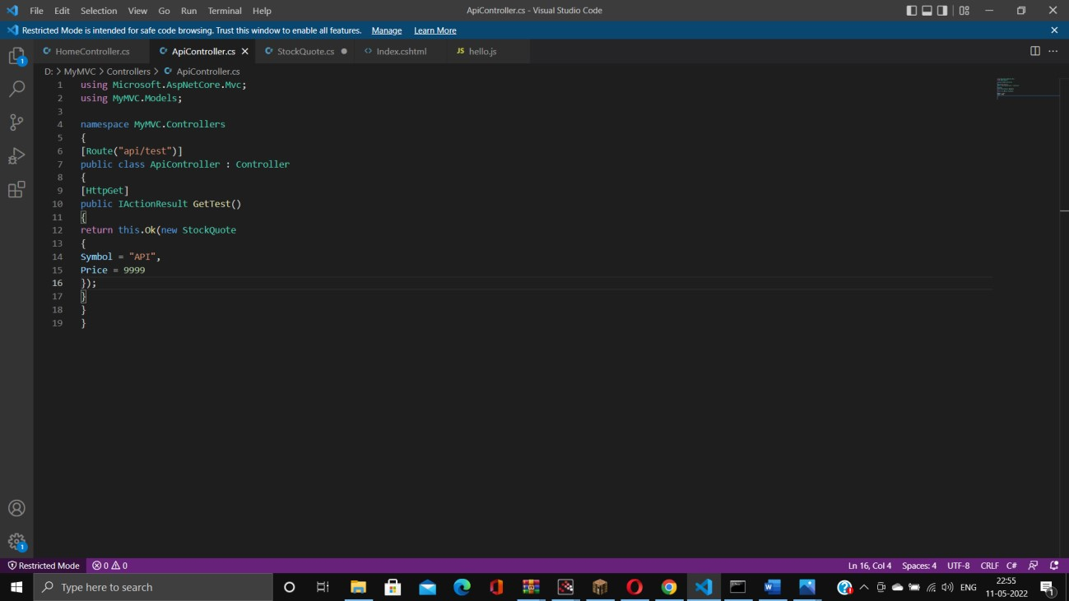

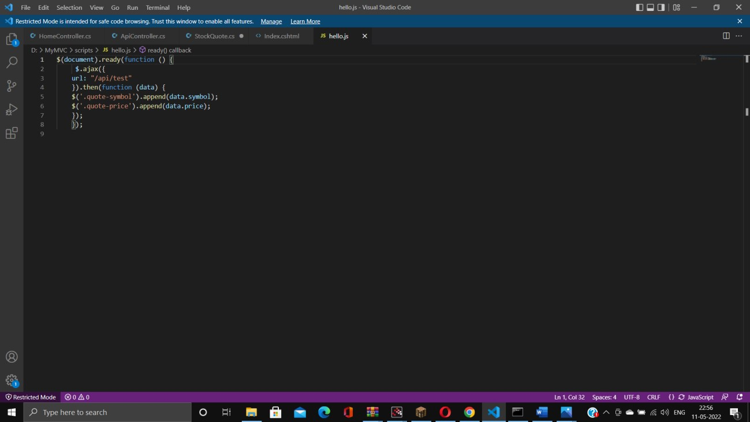

**Output: -**

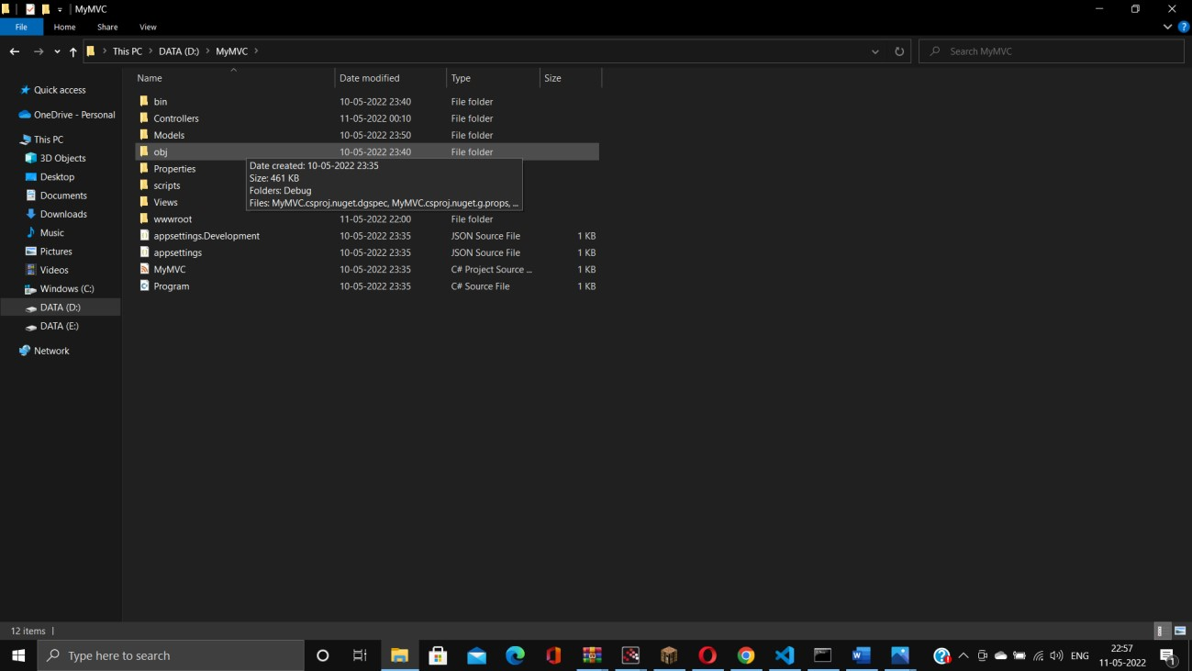

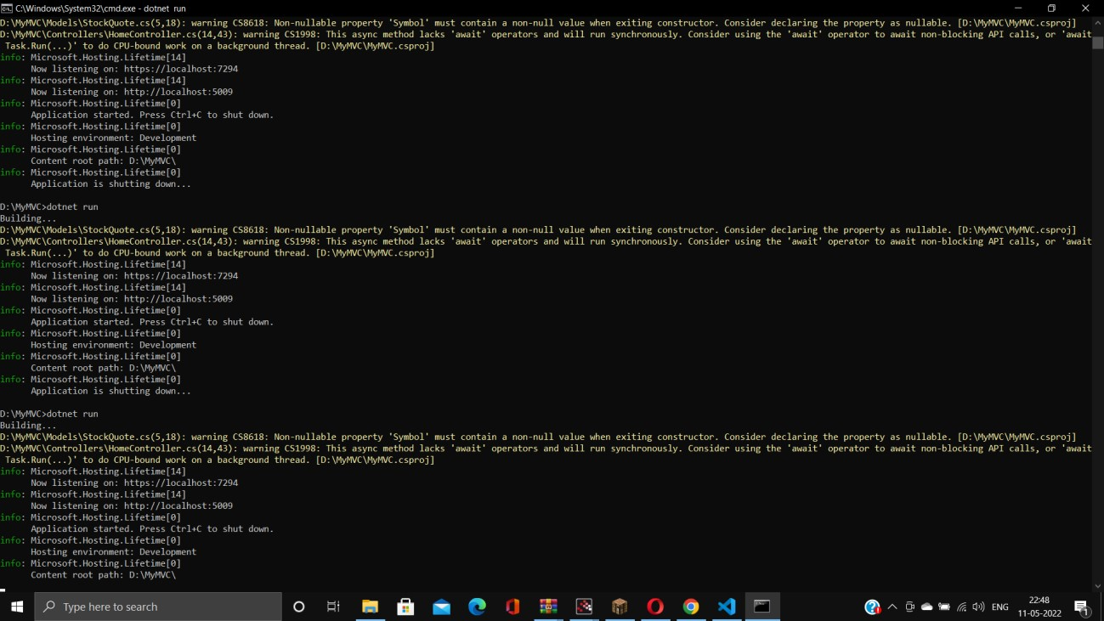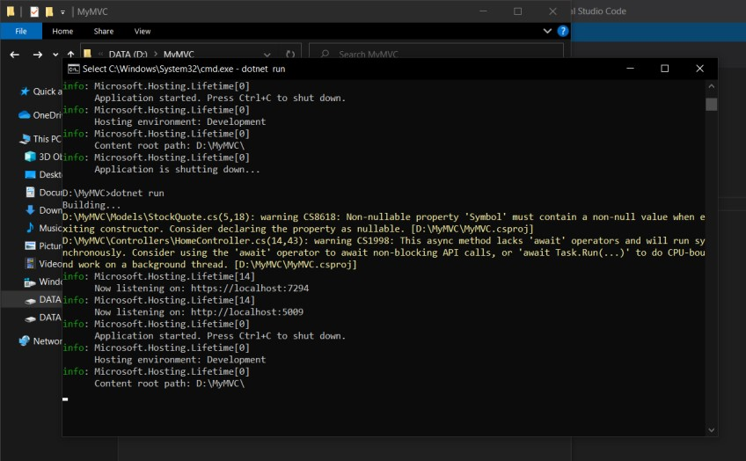

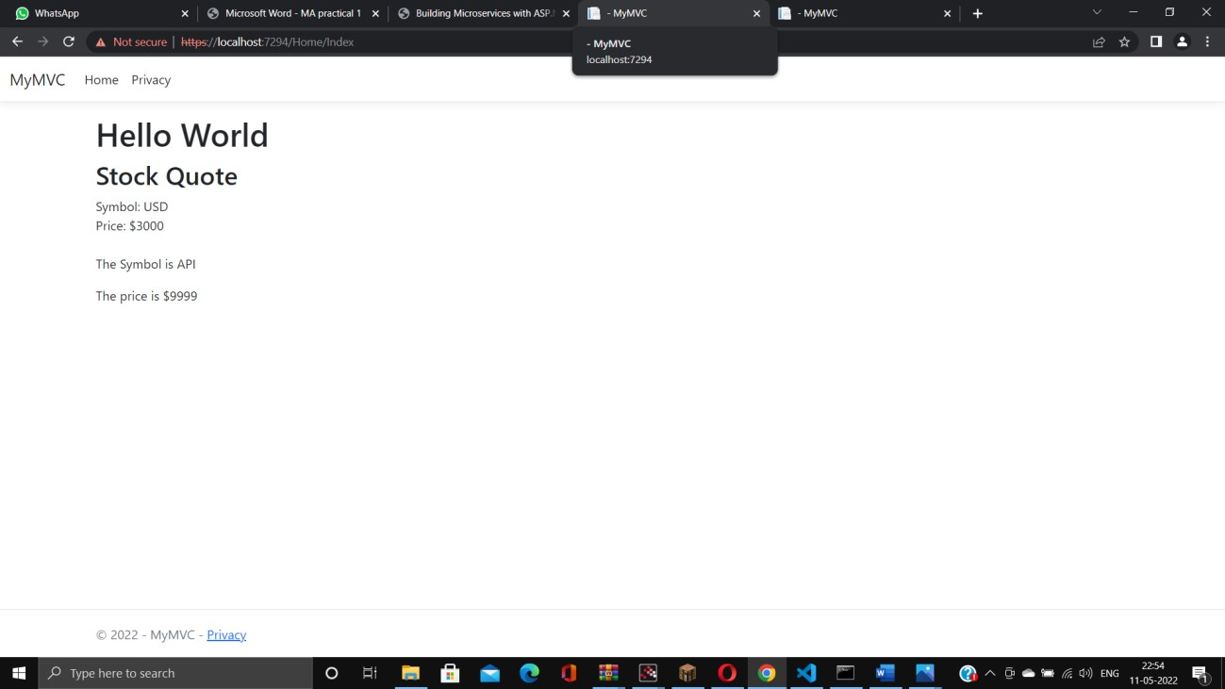

**Practical No. 2**

**Aim: -** Building ASP.NET Core REST API.

**Code Implementation: - (Include steps)**

Software requirement:

1. Download and install

To start building .NET apps you just need to download and install the .NET SDK (Software Development Kit version 3.0 above).

Link: <https://dotnet.microsoft.com/learn/dotnet/hello-world-tutorial/install>

1. Check everything installed correctly

Once you've installed, open a new command prompt and run the following command: Command prompt

> dotnet

**Create your web API**

1. Open two command prompts

Command prompt 1:

Command:

dotnet new webapi -o Glossary

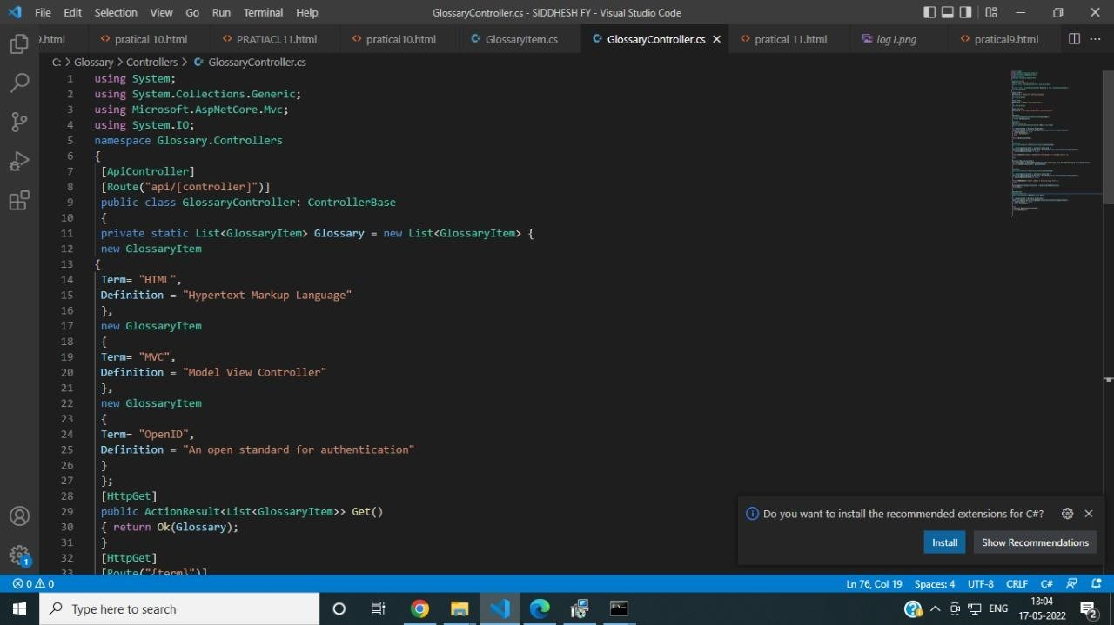

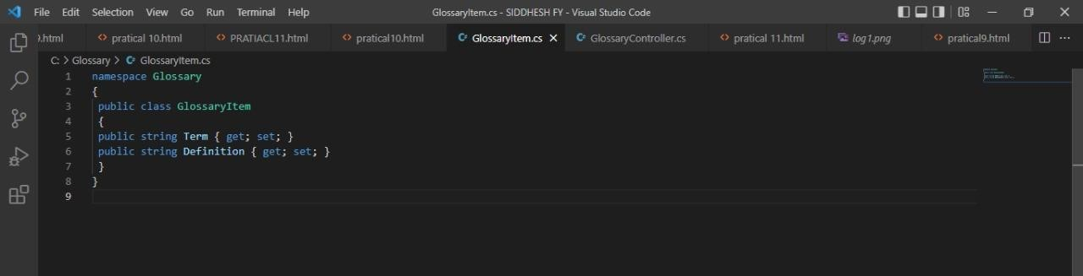

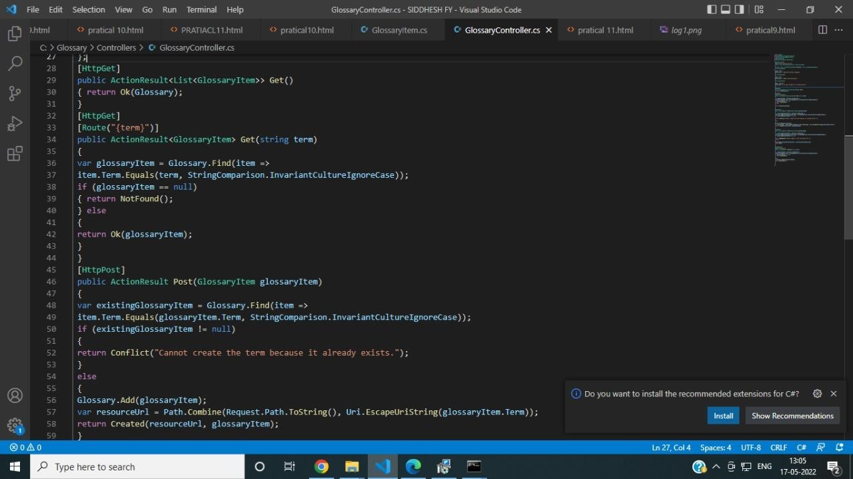

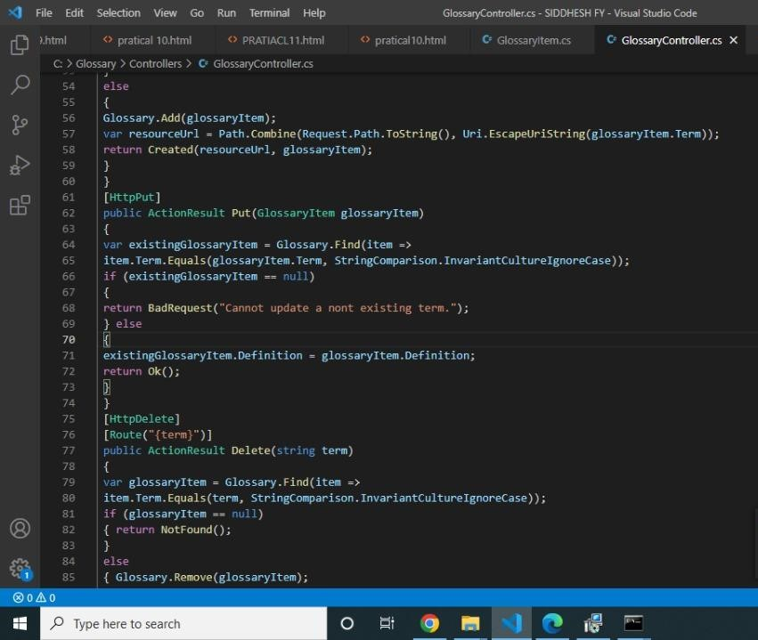 private static List<GlossaryItem> = new List<GlossaryItem>{

new GlossaryItem

{

Term= "HTML",

Definition = "Hypertext Markup Language"

},

new GlossaryItem

{

Term= "MVC",

Definition = "Model View Controller"

},

new GlossaryItem

{

Term= "OpenID",

Definition = "An open standard for authentication"

}

};

[HttpGet]

public ActionResult<List> Get()

{ return Ok (Glossary);

}

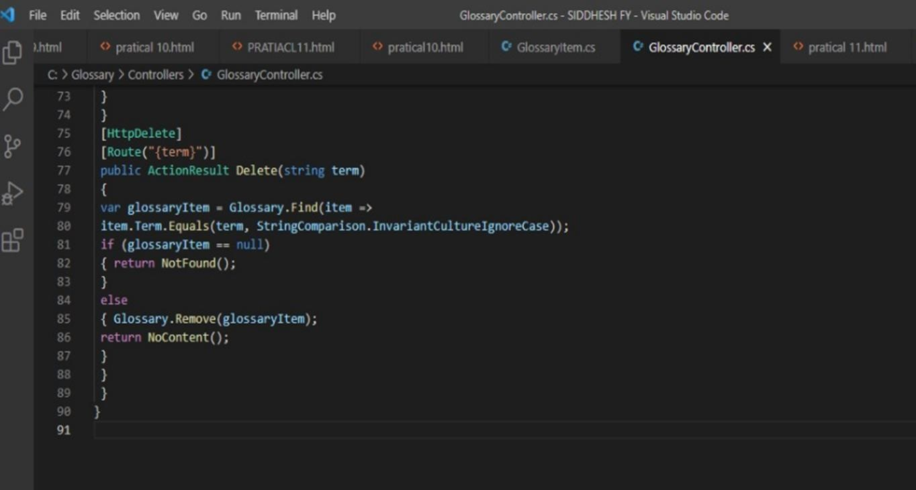

**Output :-**

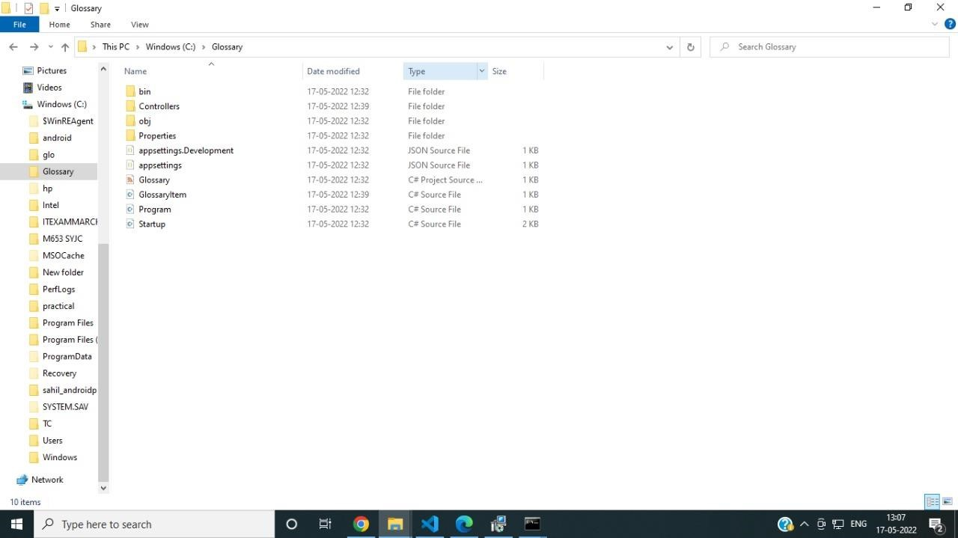

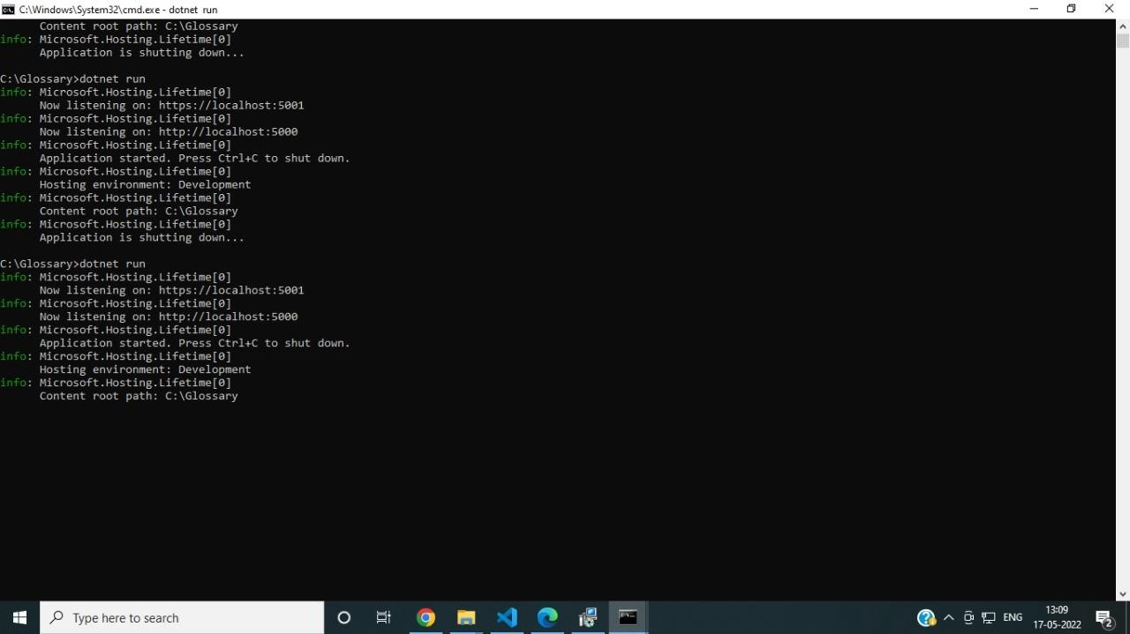

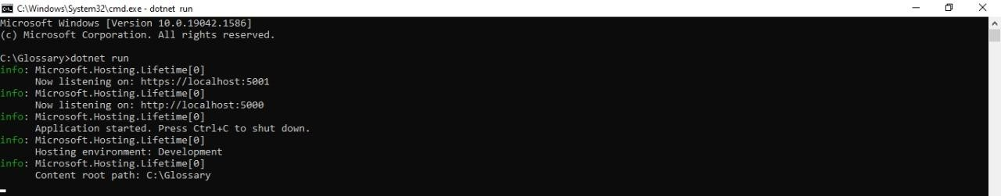

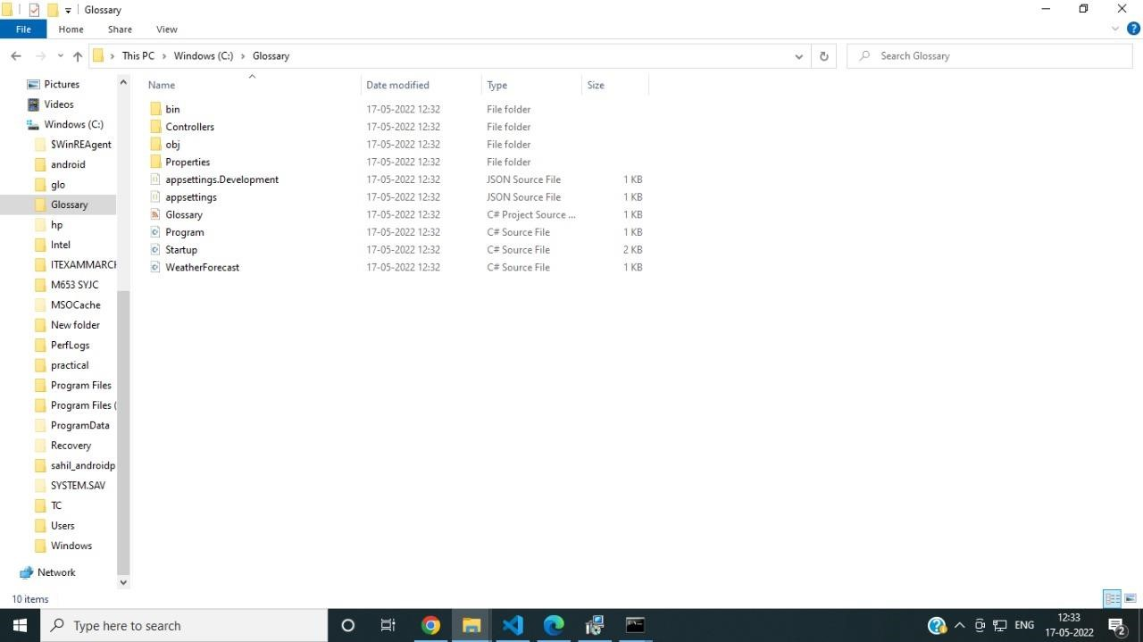

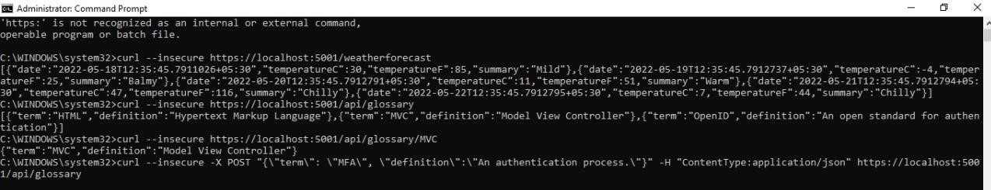

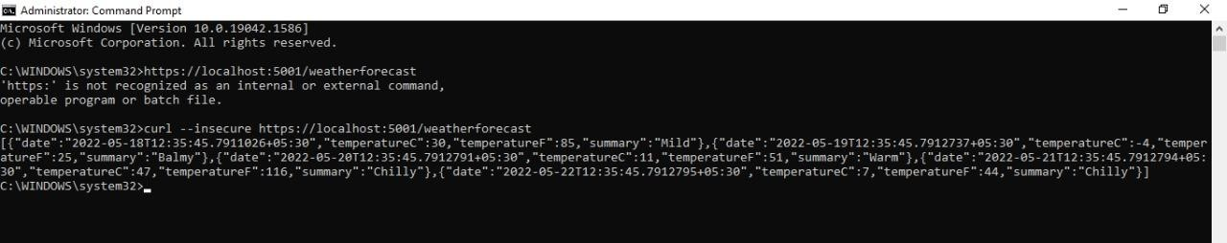

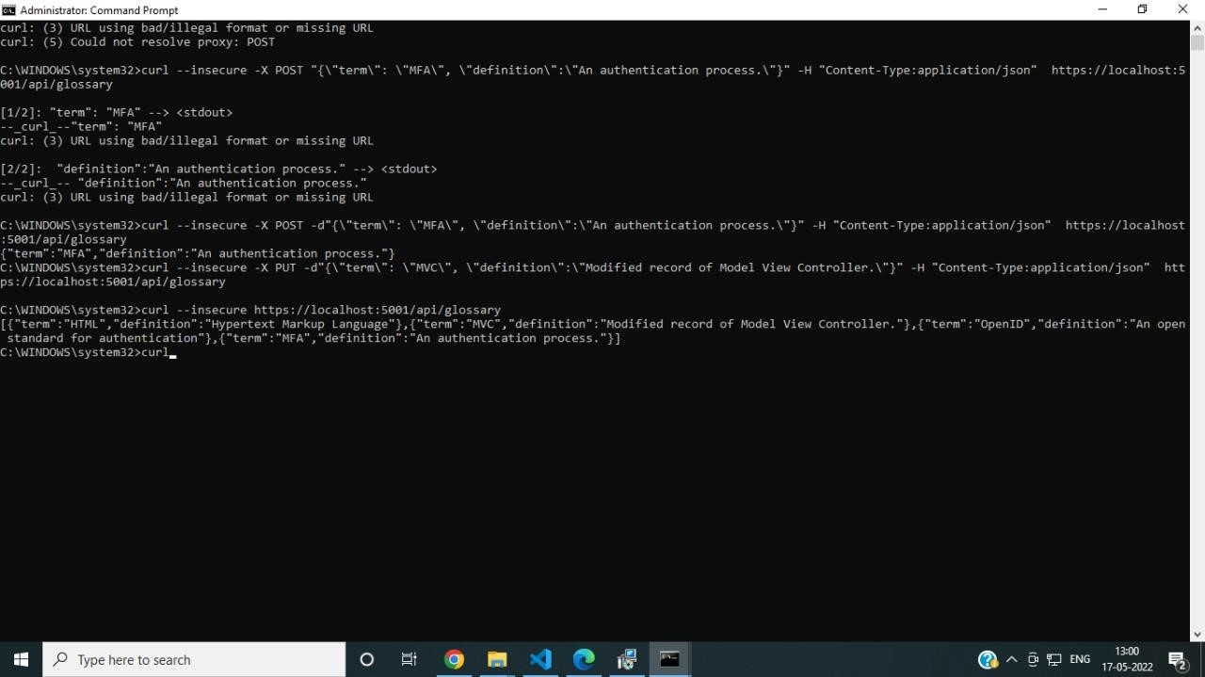

**Practical No. 3**

**Aim: -** Working with Docker, Docker Commands, Docker Images and Containers

**Code Implementation: - (Include steps)**

1. create Docker Hub account (sign up)
2. login to <https://labs.play-with-docker.com/>

Click on start

1. add new instance
2. perform following:

Method1:

To pull and push images using docker

Command: to check docker version

docker –version

Command: to pull readymade image

docker pull rocker/verse

Method 2:

Build an image then push it to docker and run it

Command : to create docker file

1. cat > Dockerfile <<EOF
2. FROM busybox
3. CMD echo “HELLO world! This is my Docker image.”
4. EOF

**Output: -**

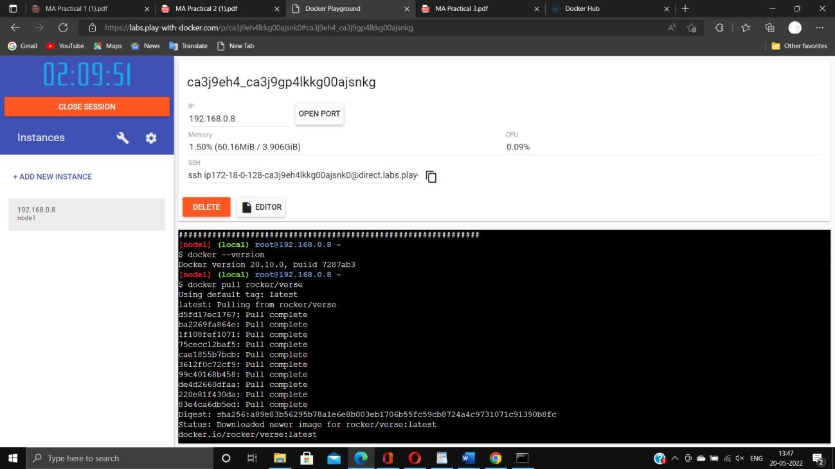

Command : to build image from docker file

dokcer build –t kbdocker11/repo2 .

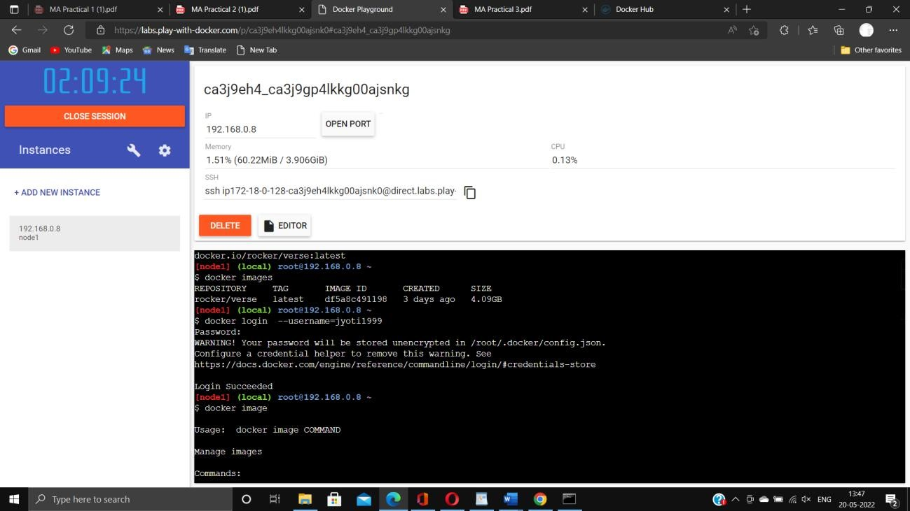

Now Login to docker hub and create repository

Click on Create button

Now check repository created

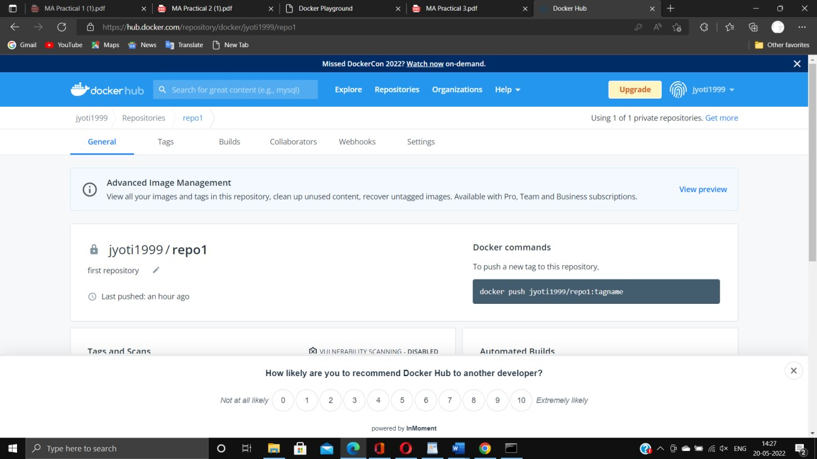

Command: to login to your docker account docker login

–username=kbdocker11 password:

note: kbdocker11 is my docker ID .

You will use your docker ID here.

And enter your password .

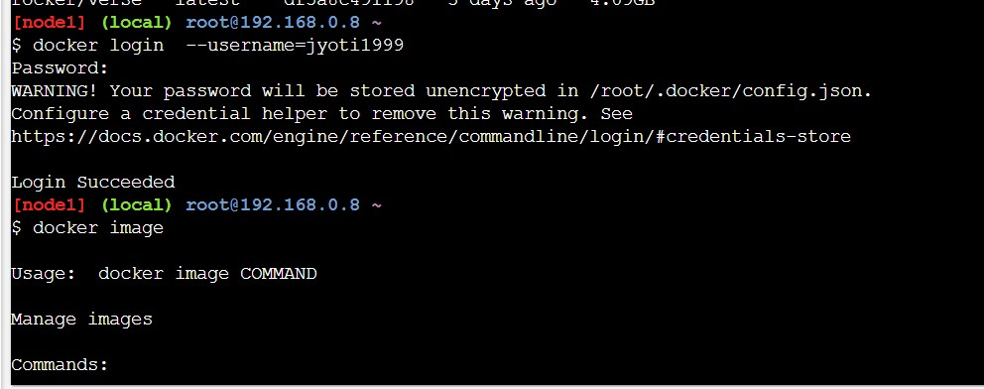

docker tag 8c3e4e2c3e kbdocker11/repo1:firsttry

note: here 8c3e4e2c3e this is image id which you can get from docker images command.

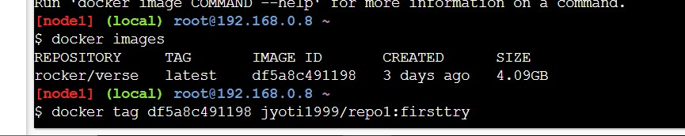

Command: to push image to docker hub account

Docker push kbdocker11/repo1.firsttry

note: firsttry is tag name created above

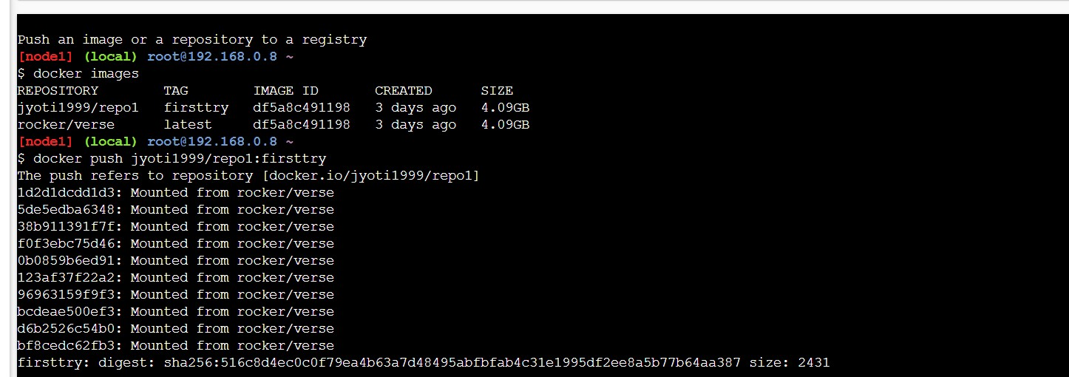

**Practical No. 4**

**Aim:-** Installing software packages on Docker, Working with Docker Volumes and Networks.

**Code Implementation:- (Include steps)**

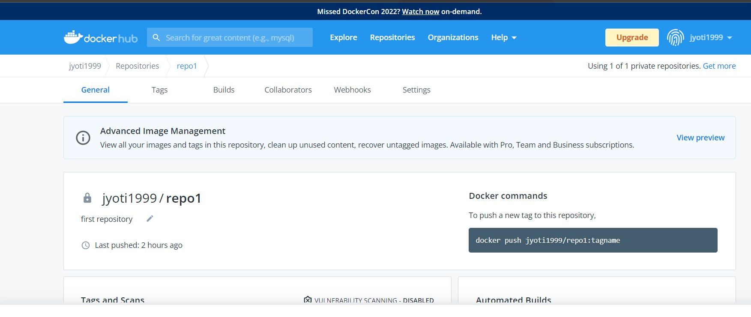

Click on tags and check

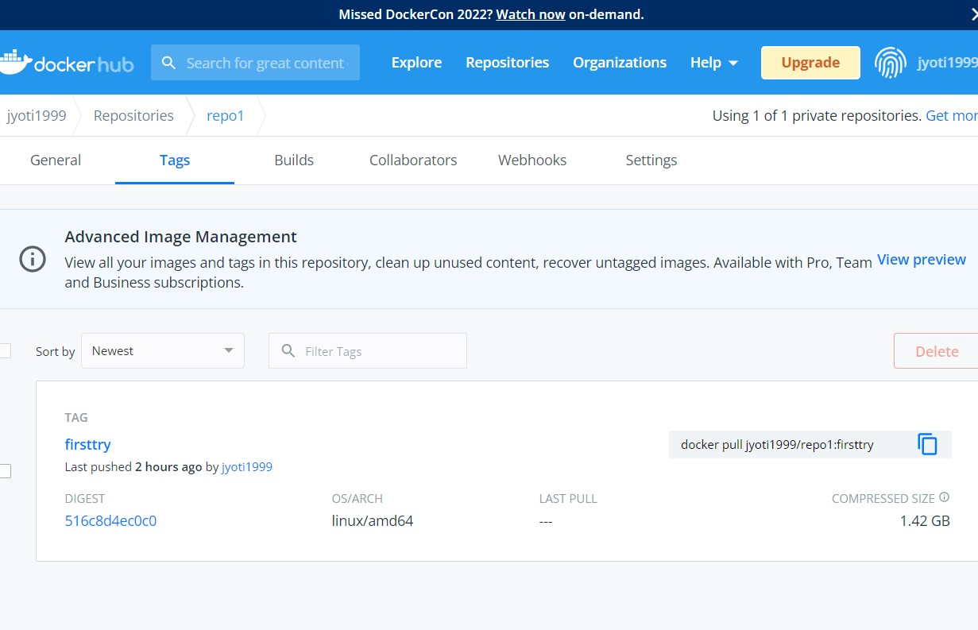

**Practical No. 5**

**Aim:-** Working with Circle CI for continuous integration

**Code Implementation:- (Include steps)**

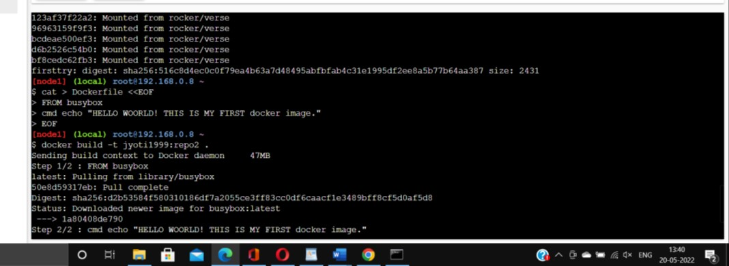

**Method 2:**

Build an image then push it to docker and run it

Command: to build image from docker file

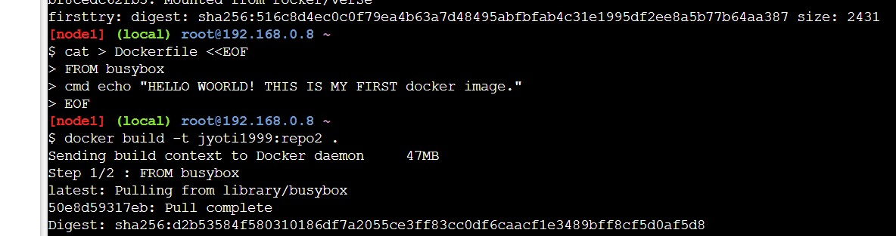Docker build-t kbdocker11/repo2.

**Command : to check docker images**

**Docker images**

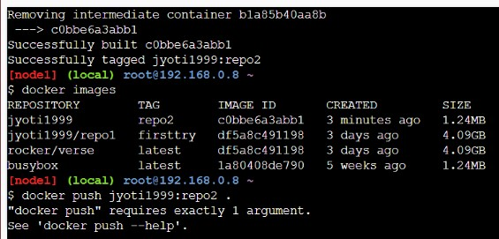

**Command : to push image to docker hub**

**Docker push kbdocker11/repo2.**

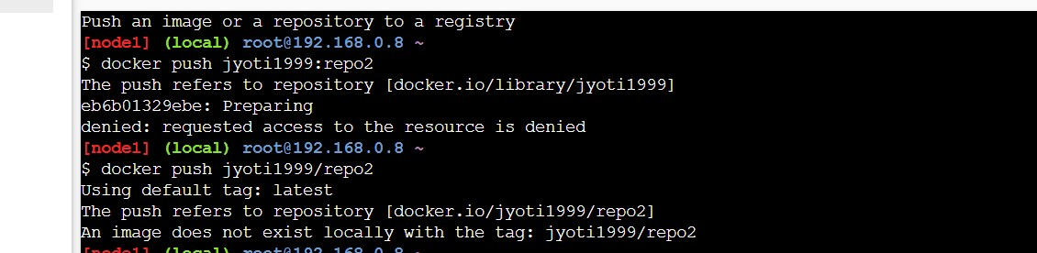

**Practical No. 6**

**Aim:-** Creating Microservice with ASP.NET Core.

**Code Implementation:- (Include steps)**

**Now check it on docker hub**

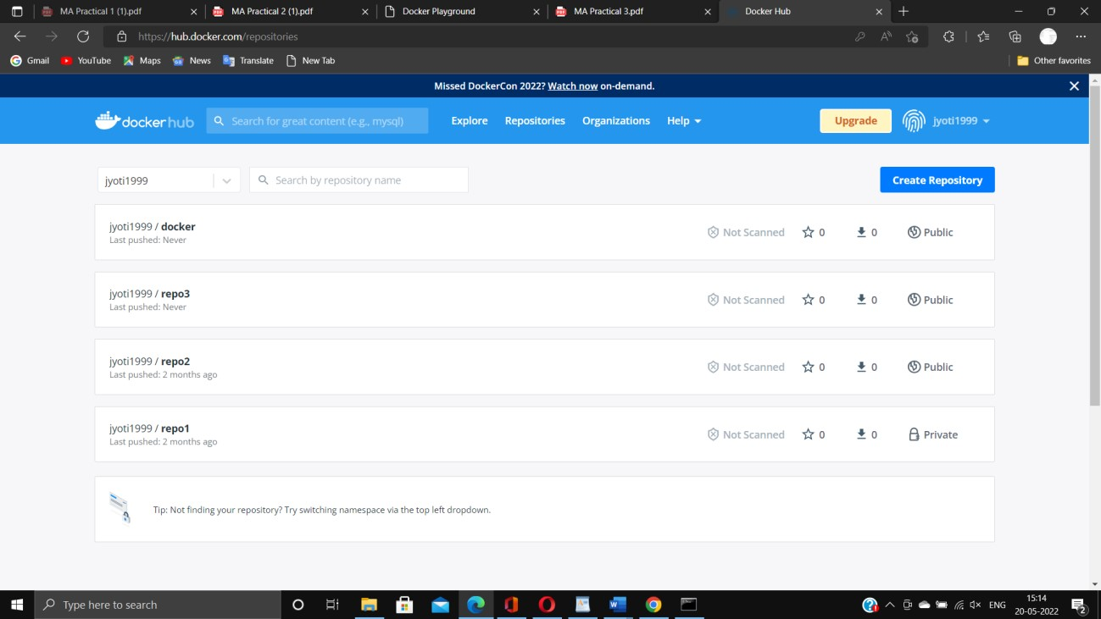

**Docker image: docker run kbdocker11/repo2**

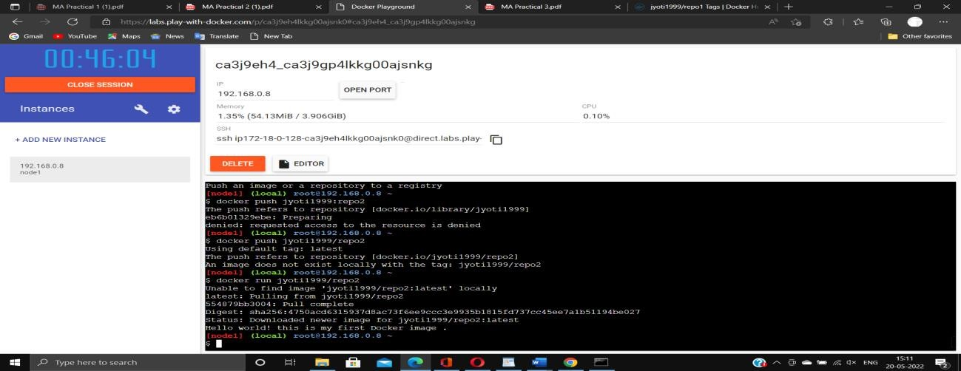

**Practical No. 4**

**Aim: -** Installing software packages on Docker, Working with Docker Volumes and Networks

**Code Implementation: - (Include steps)**

Step 1: create a microservice with docker support

Step2:update docker file and docker compose override.yml

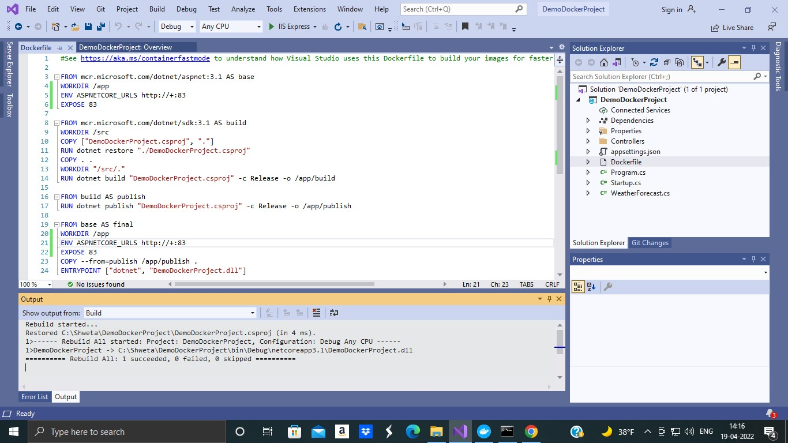

Step 3:

Run the application using visual studio

Step 4: run the application using docker command

**Output: -**

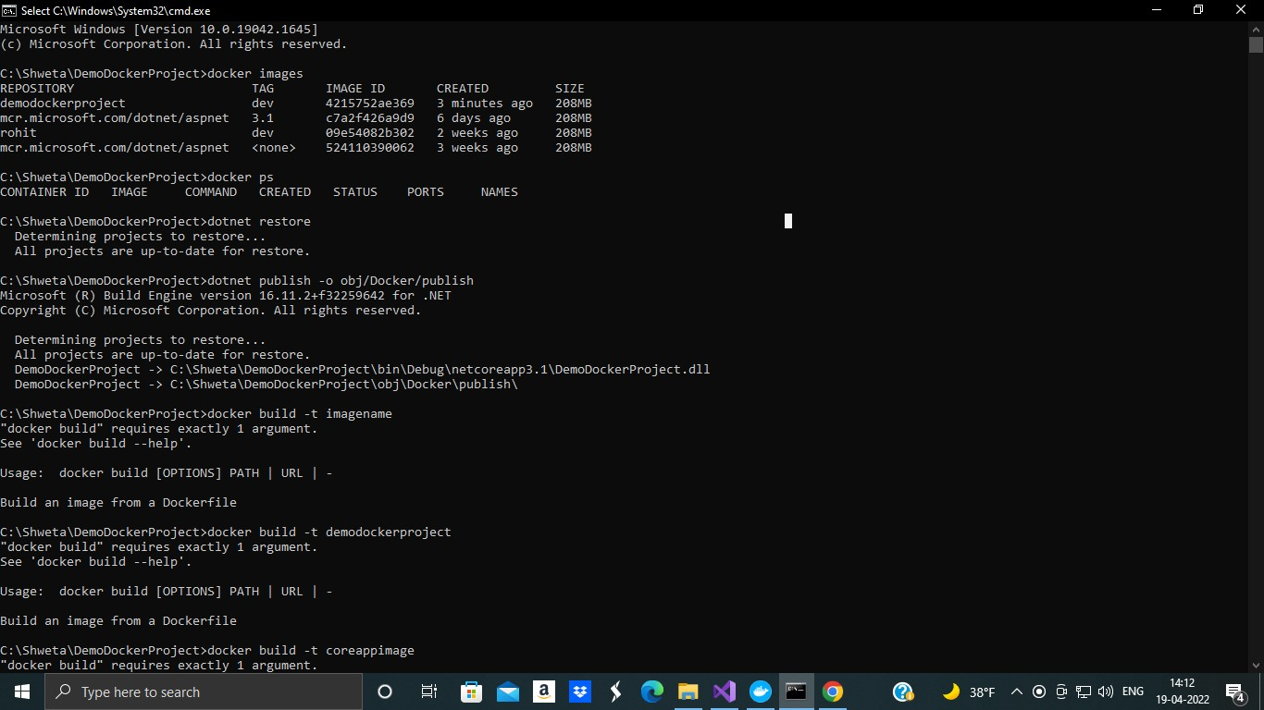

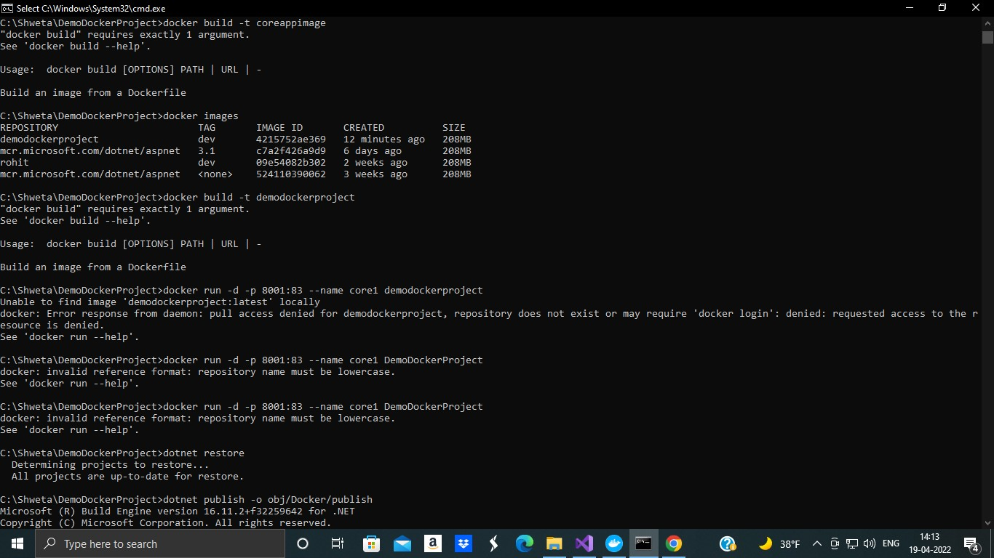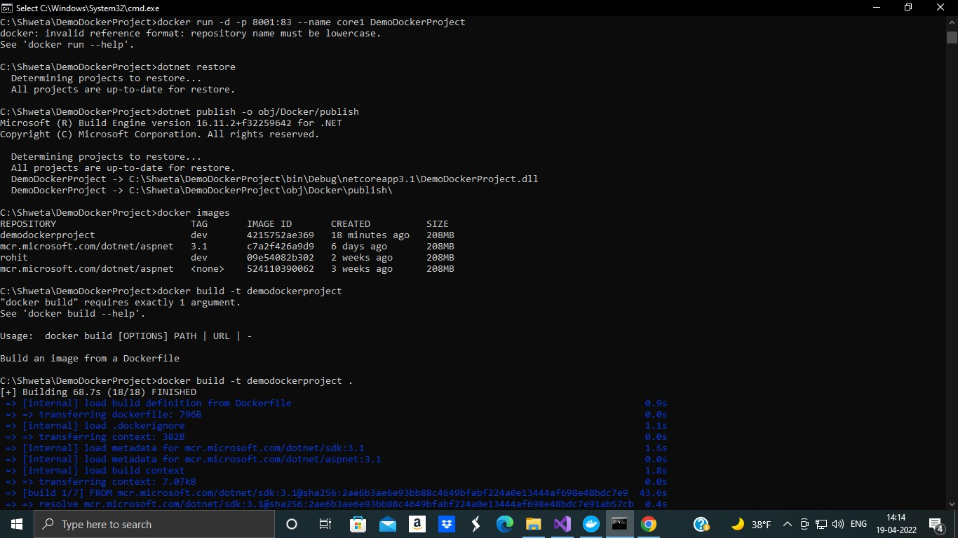

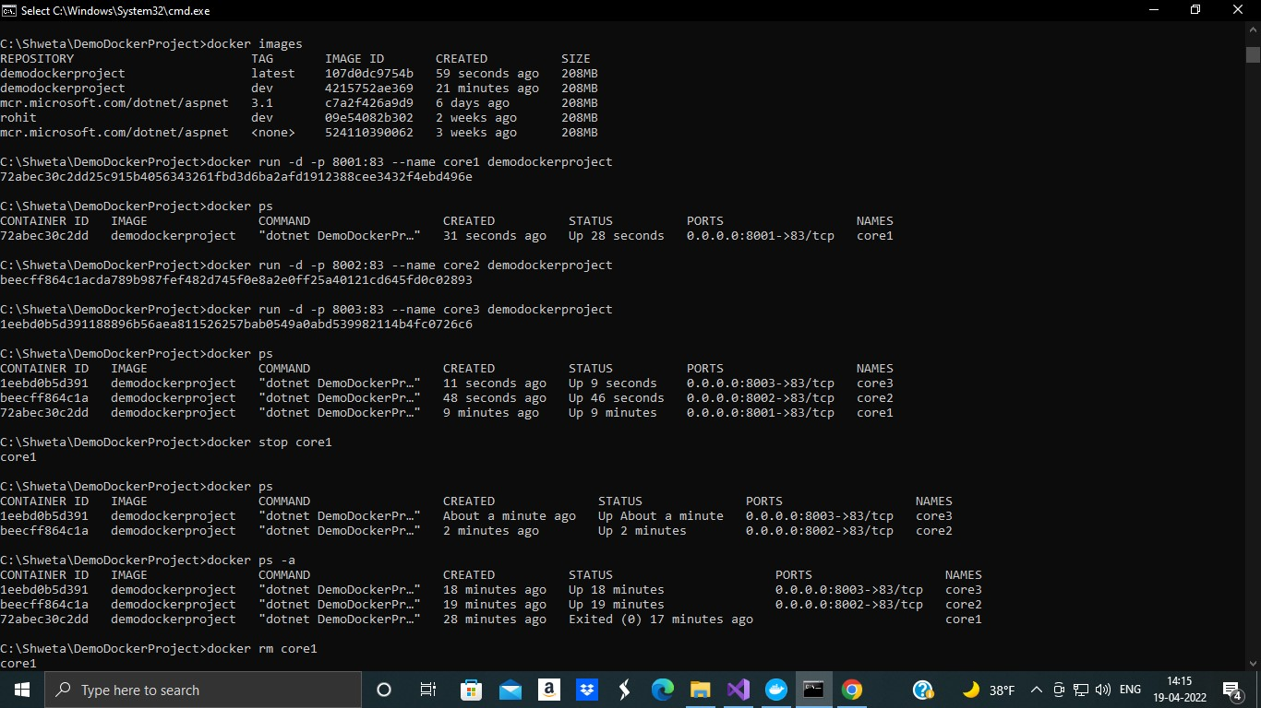

Working with docker volumes

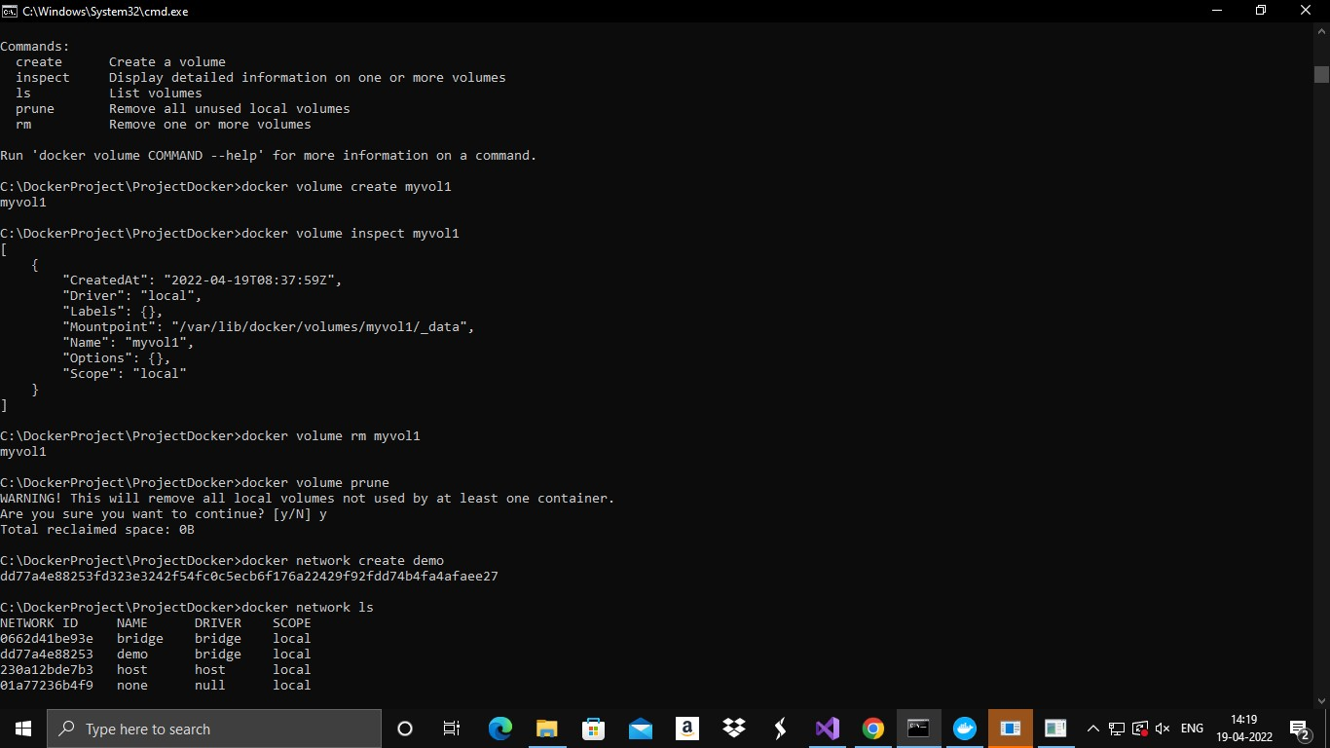

Docker network

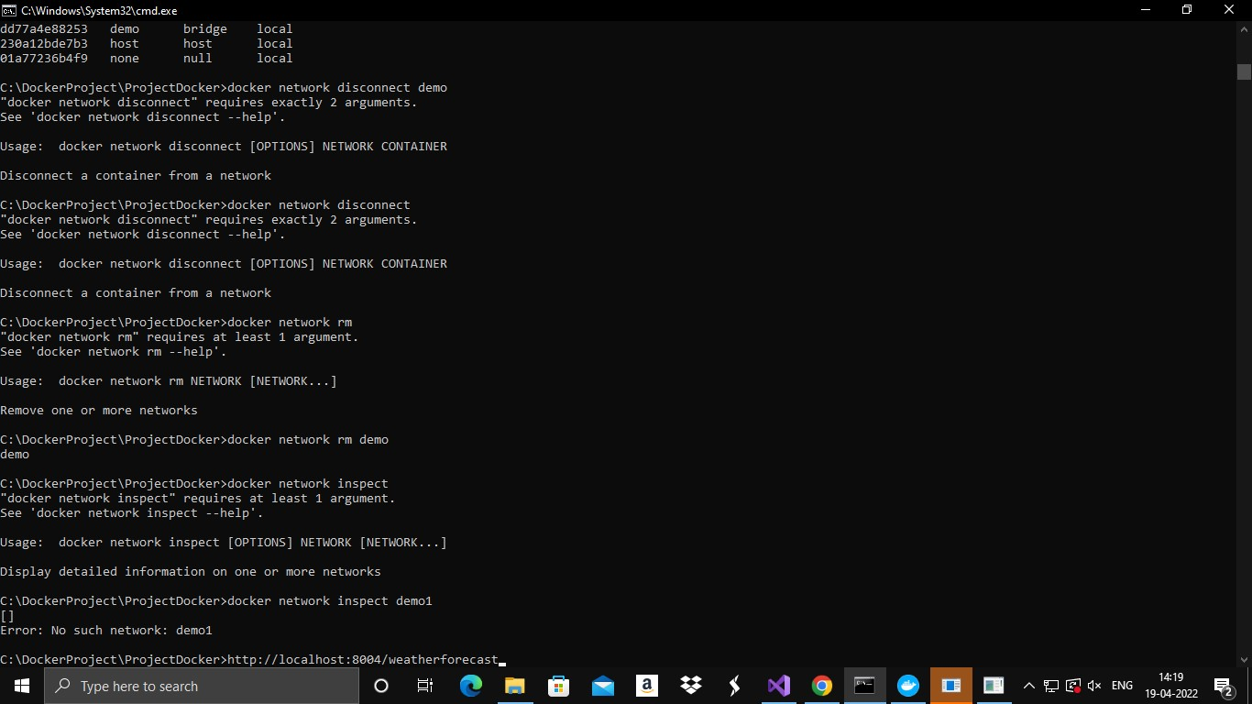



**Practical No.5**

**Aim: -** Working with circle Cl for continuous integration

**Code Implementation : (Include steps)**

Step 1 - Create a repository

1. Log in to GitHub and begin the process to create a new repository.
2. Enter a name for your repository (for example, hello-world).
3. Select the option to initialize the repository with a README file.
4. Finally, click Create repository. 5. There is no need to add any source code for now.

Step 2 - Set up CircleC

1. Navigate to the CircleCI Projects page. If you created your new repository under an organization, you will need to select the organization name.

1. You will be taken to the Projects dashboard. On the dashboard, select the project you want to set up (hello-world).
2. Select the option to commit a starter CI pipeline to a new branch, and click Set Up Project. This will create a file .circleci/config.yml at the root of your repository on a new branch called circleci-projectsetup.

Step 3 - Your first pipeline

On your project’s pipeline page, click the green Success button, which brings you to the workflow that ran (say-hello workflow).

Within this workflow, the pipeline ran one job, called say-hello. Click say-hello to see the steps in this job:

1. Spin up environment
2. Preparing environment variables
3. Checkout code d. Say hello Step 4 - Break your build

In this section, you will edit the .circleci/config.yml file and see what happens if a build does not complete successfully.

It is possible to edit files directly on GitHub

**Output: -**

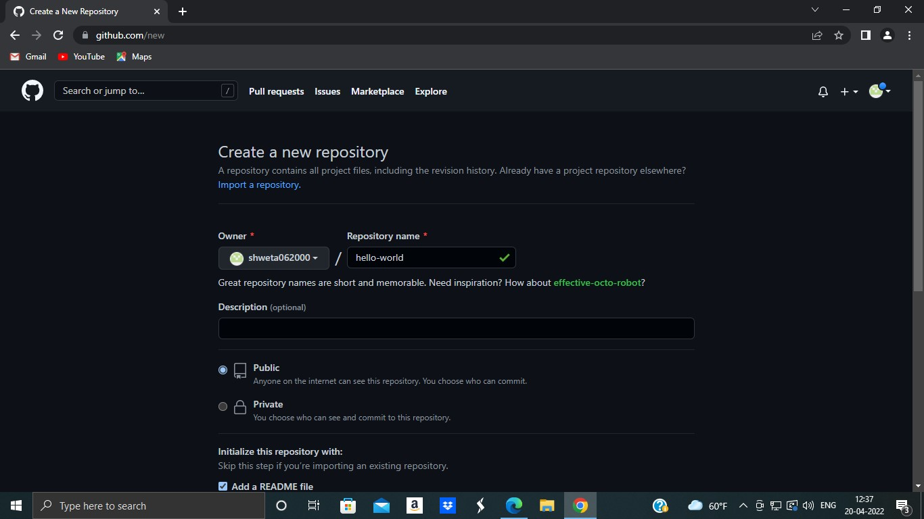

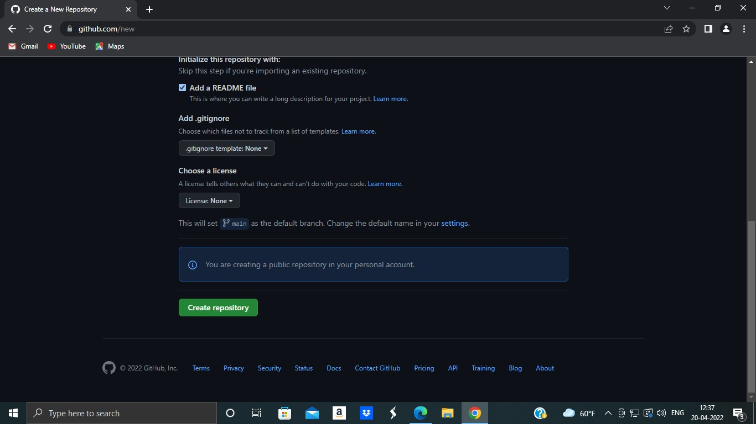

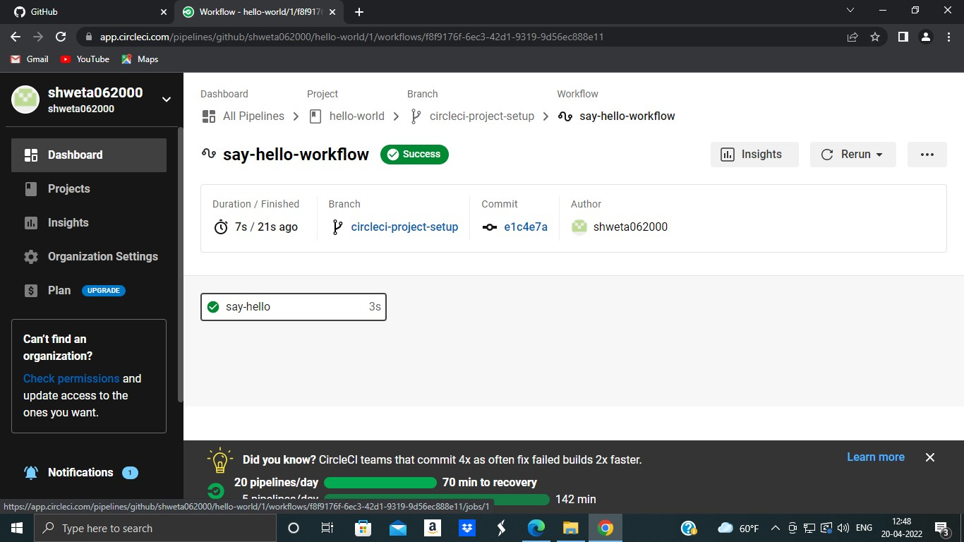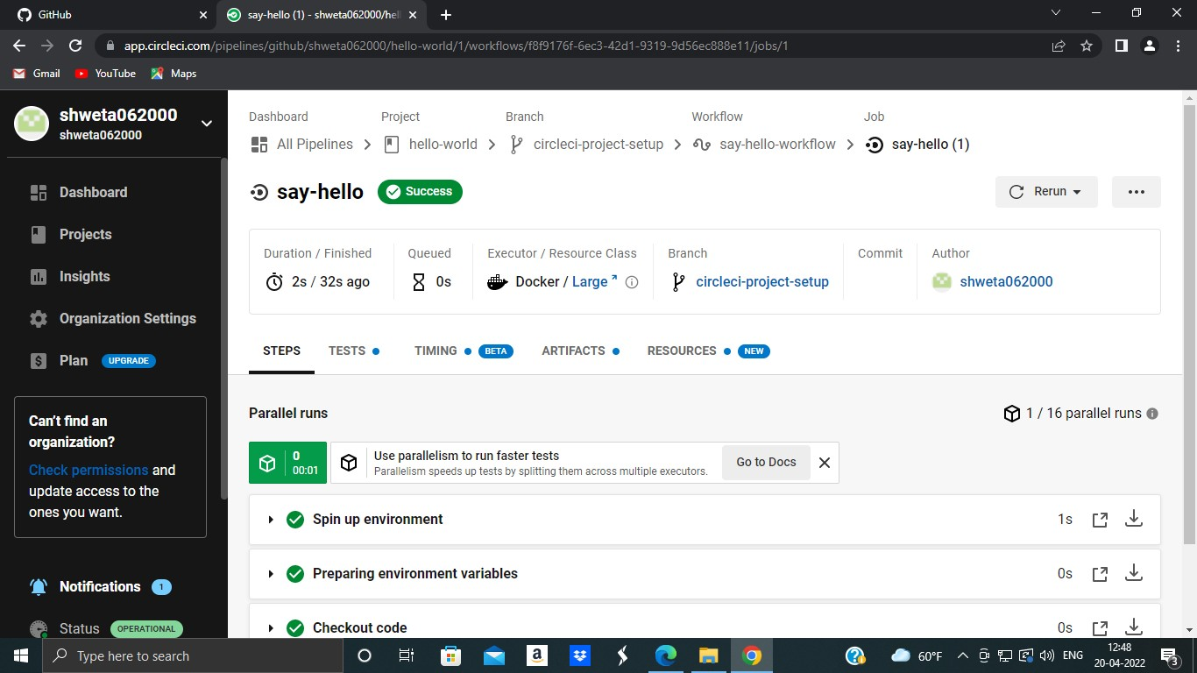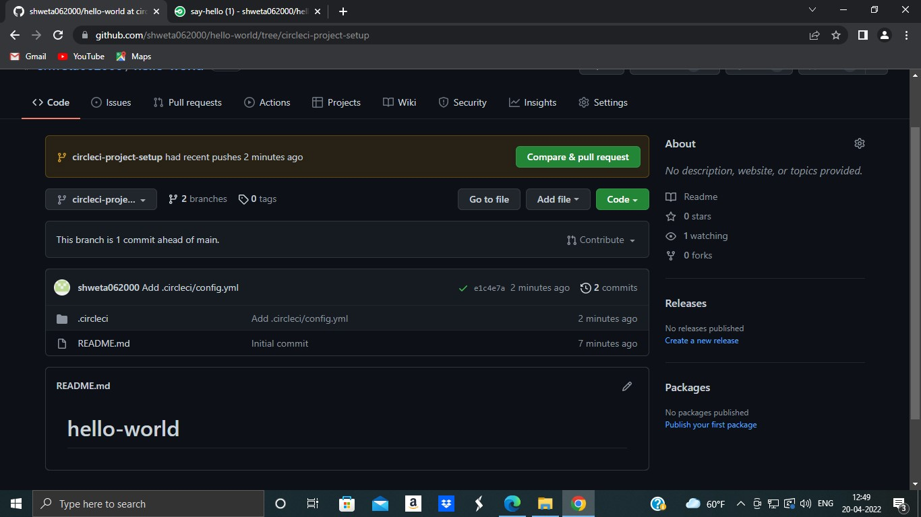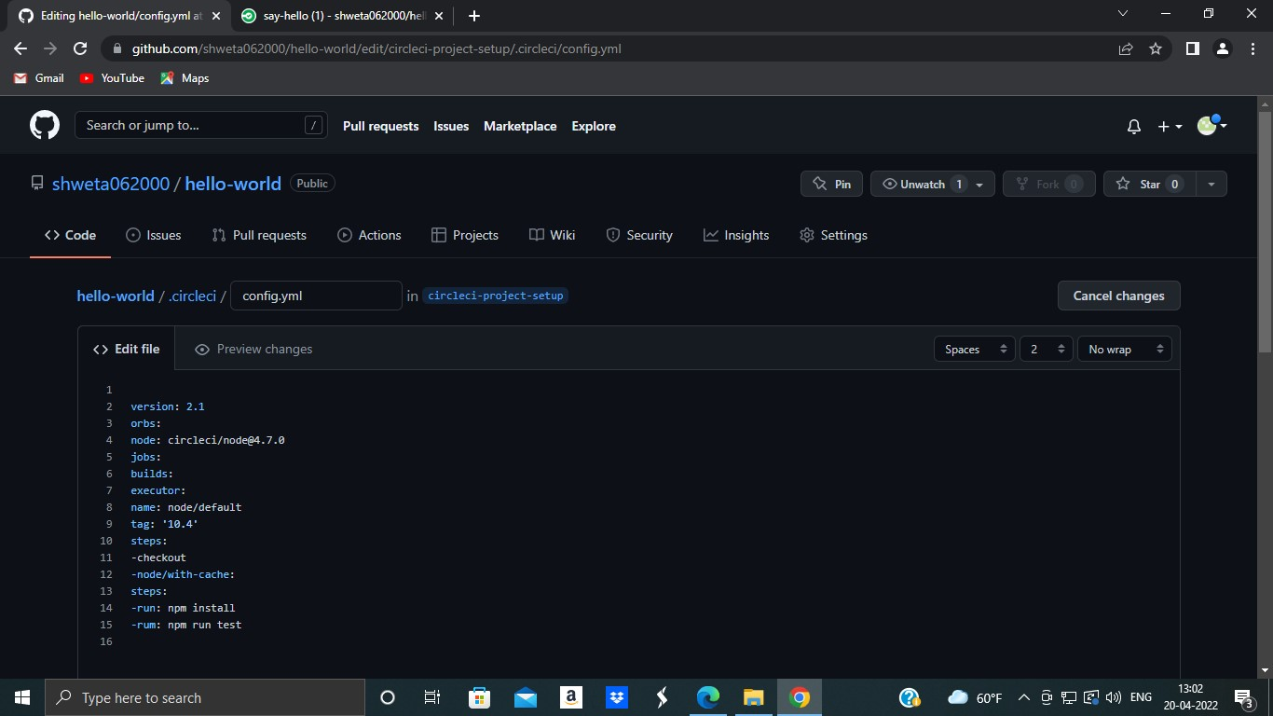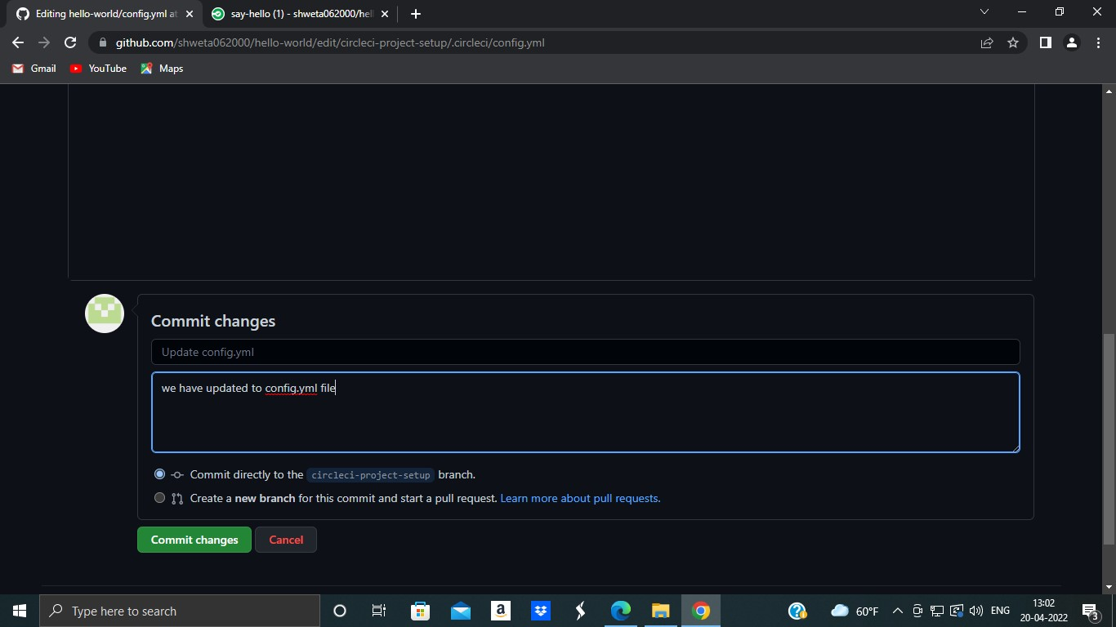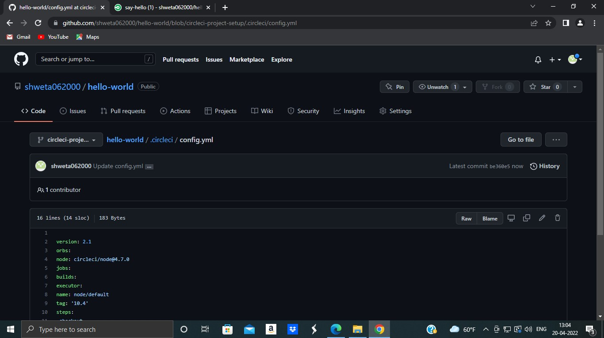

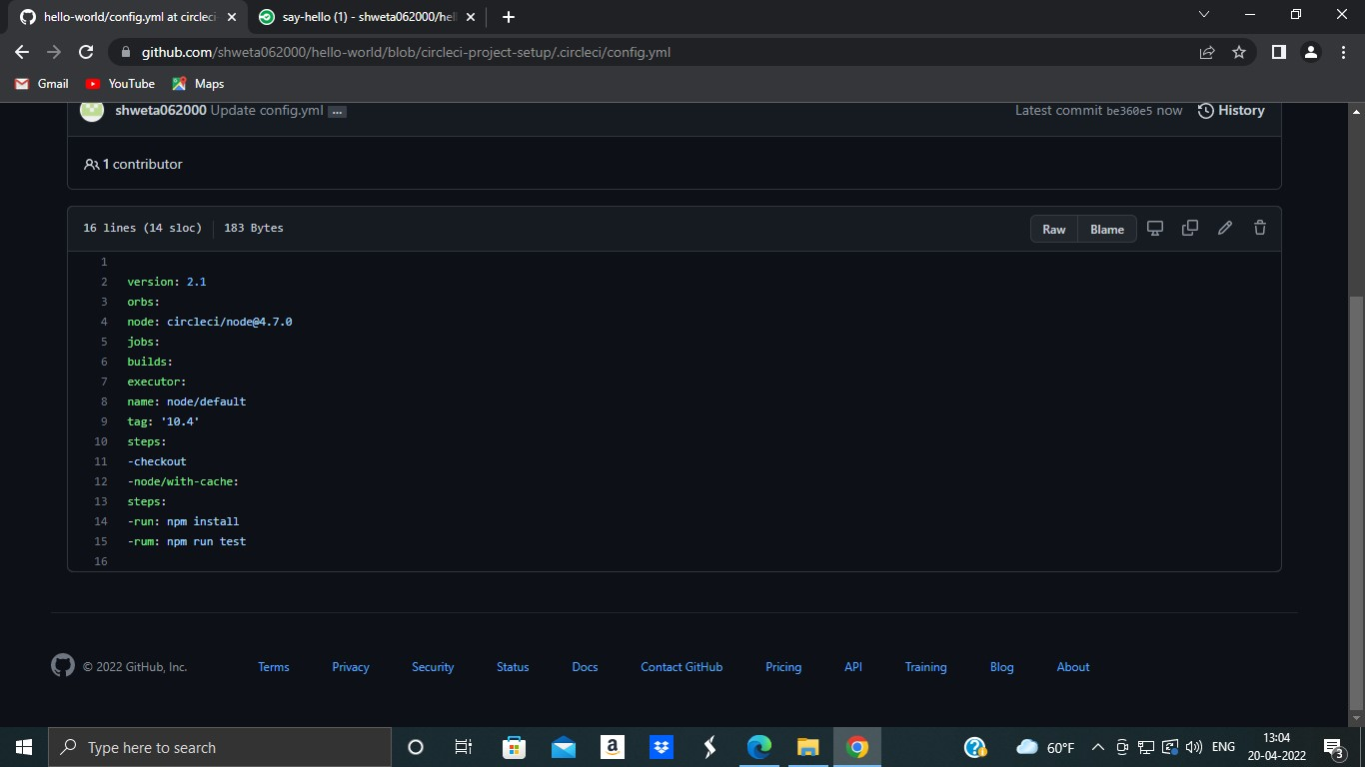

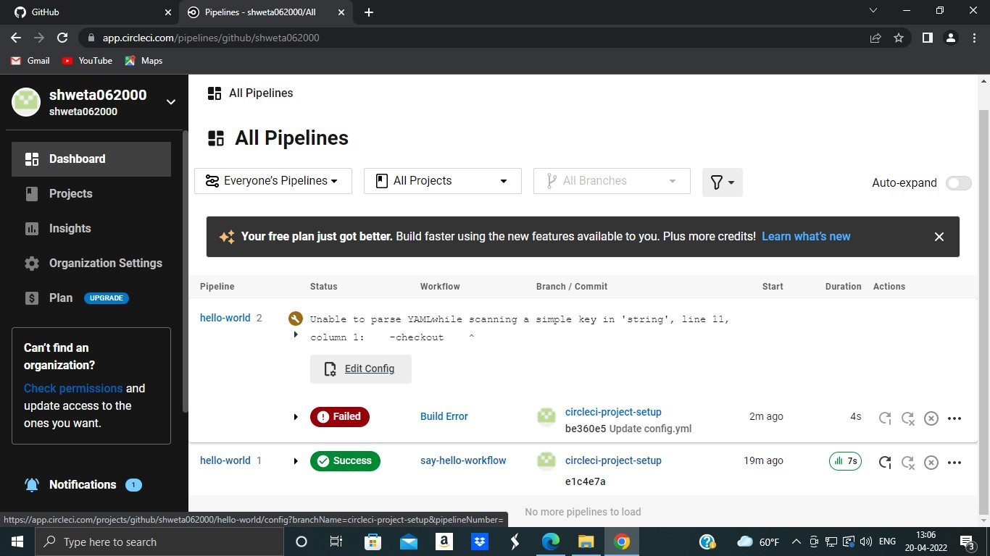

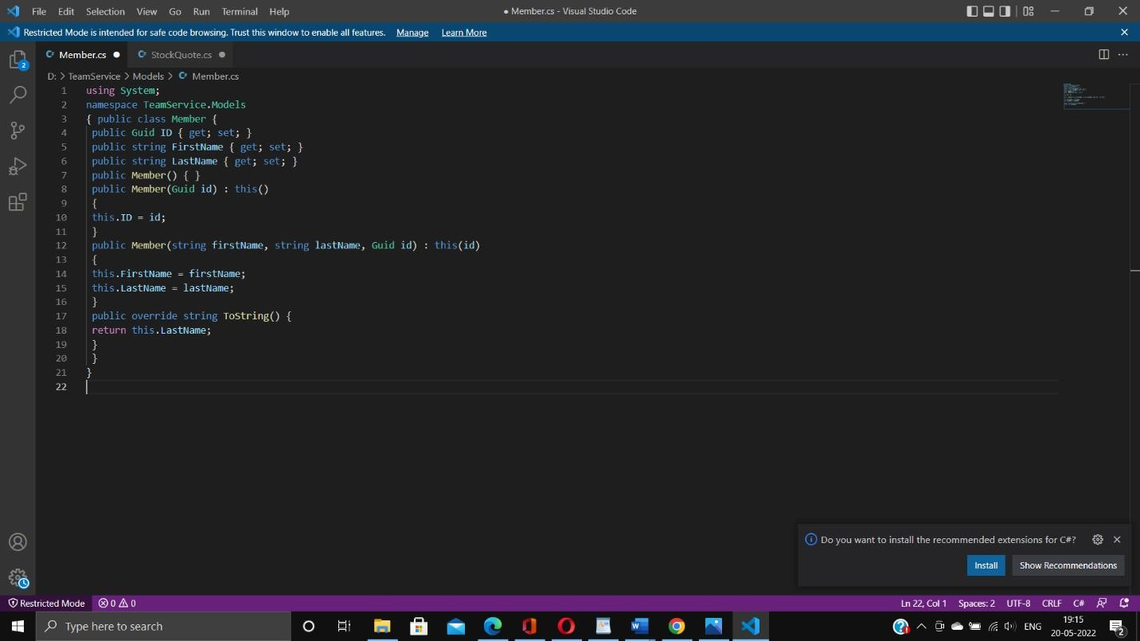

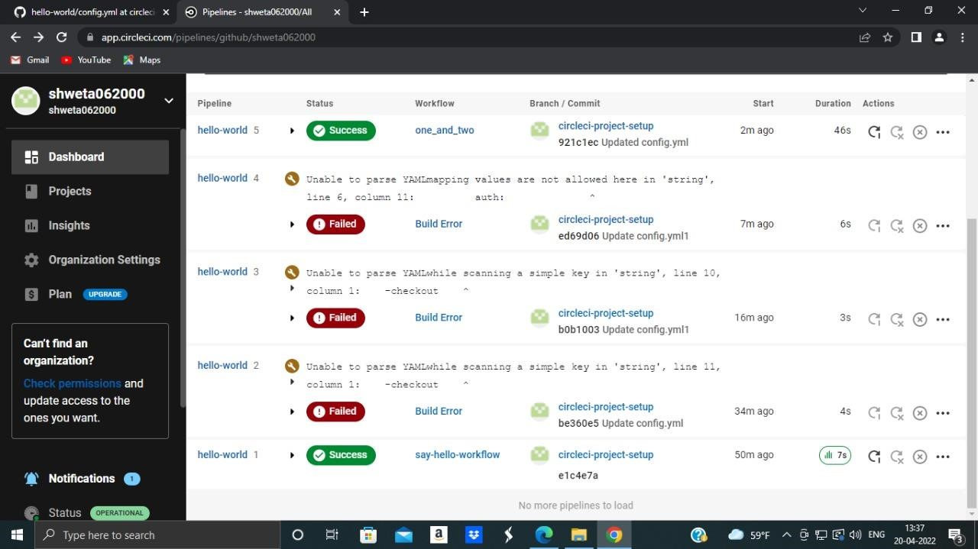

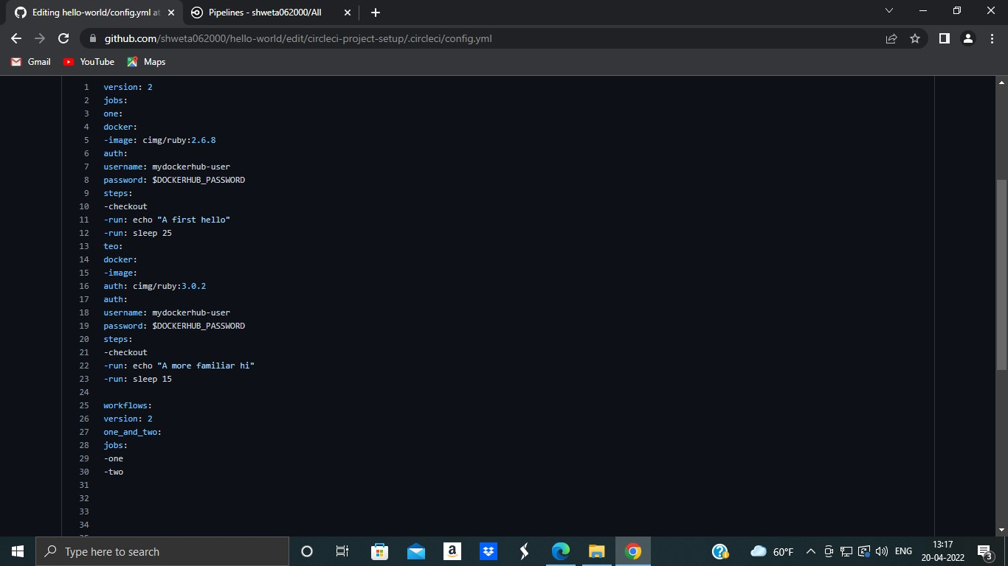

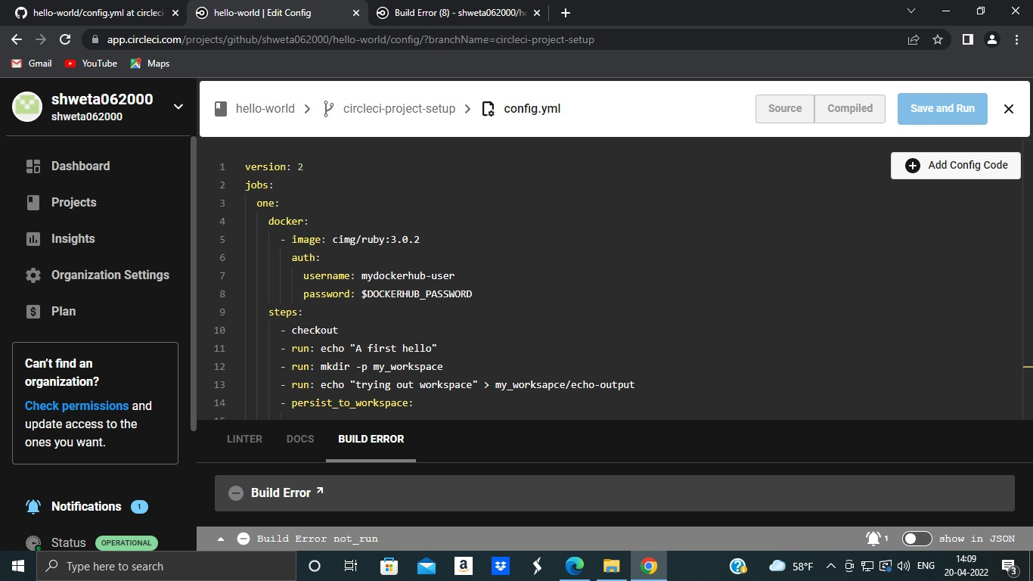

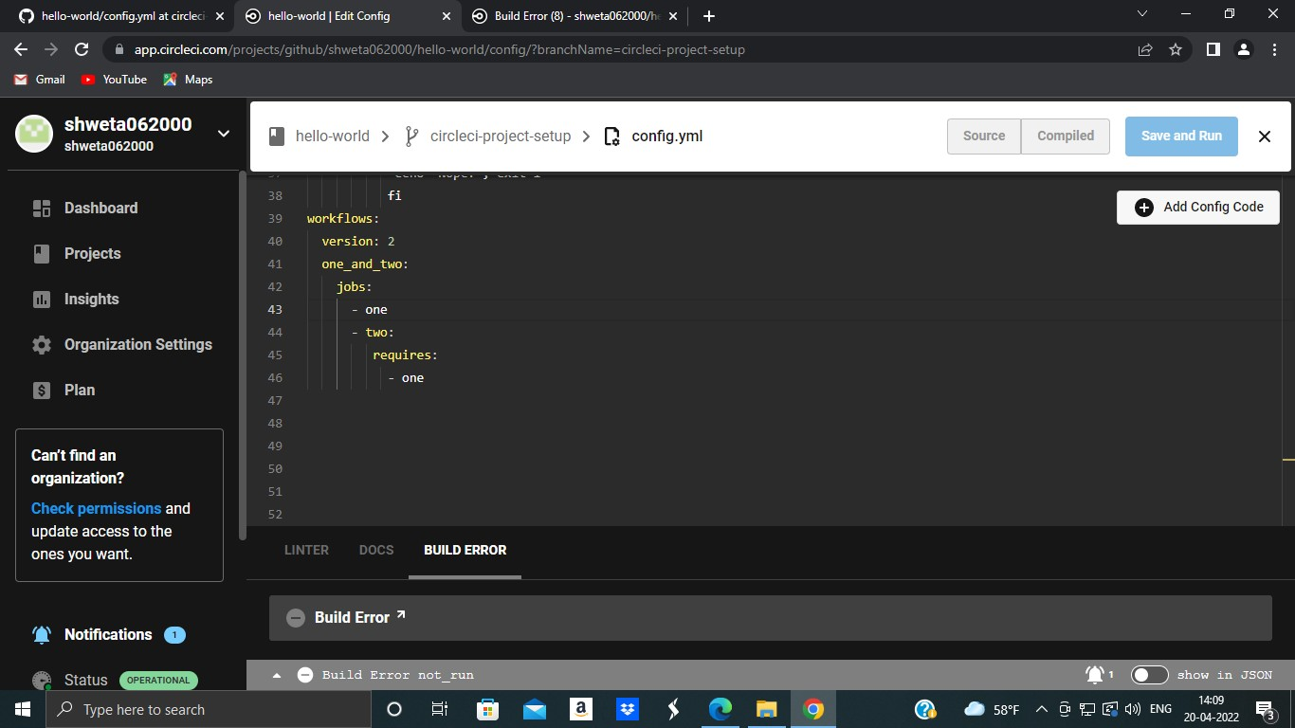

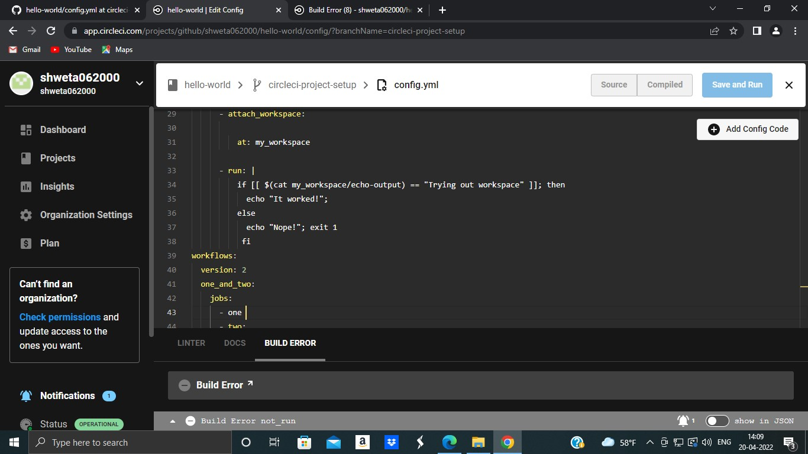

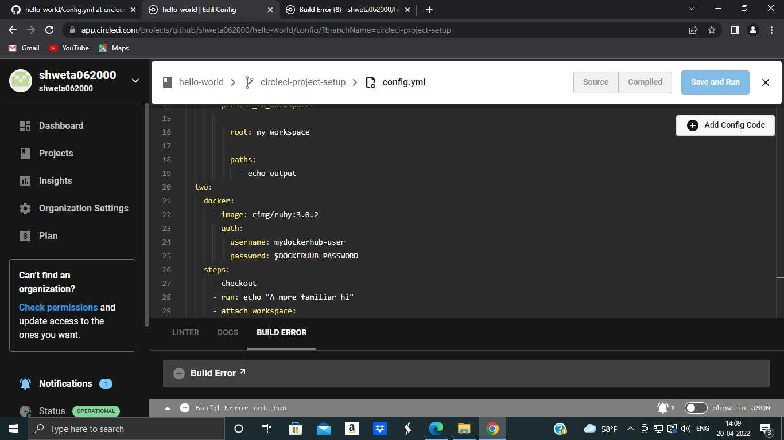

**Practical No: 6**

**Aim:-** Creating Microservice with ASP.NET core Code

**Code implementation: (Include steps)**

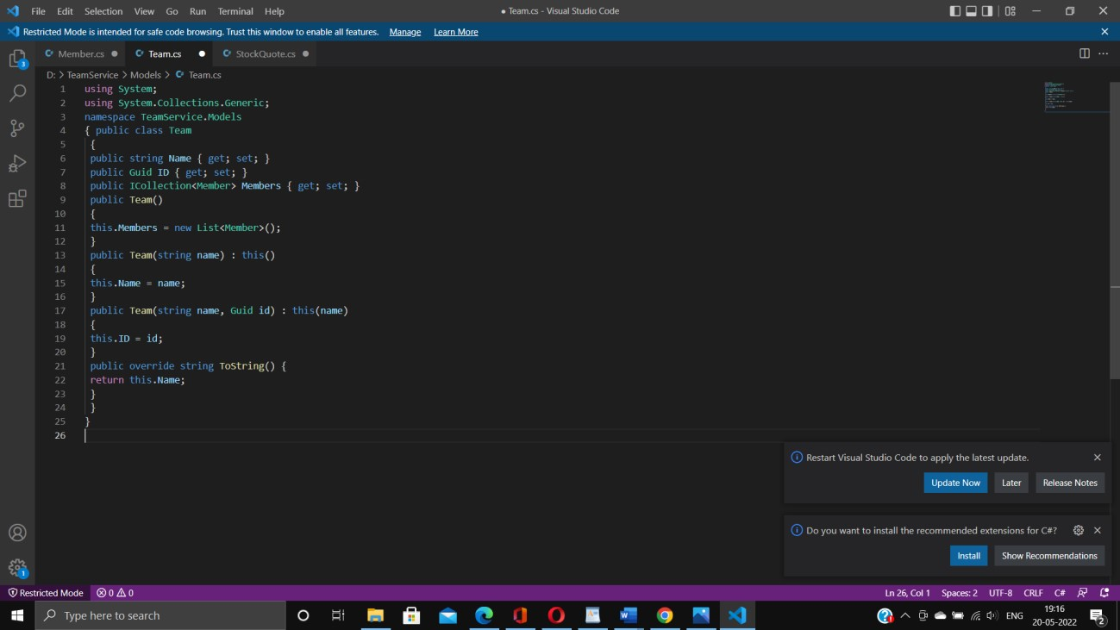

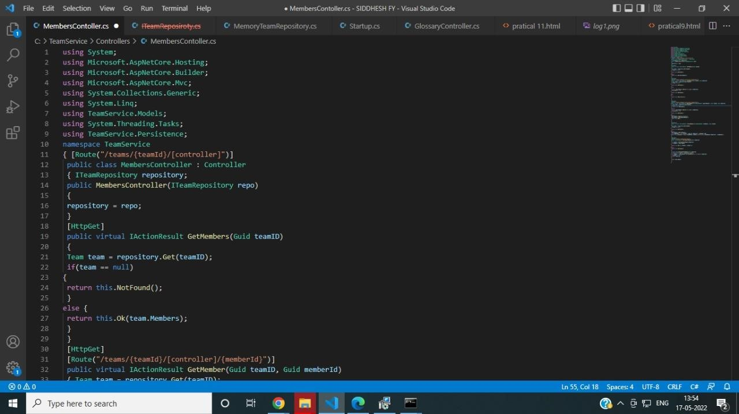

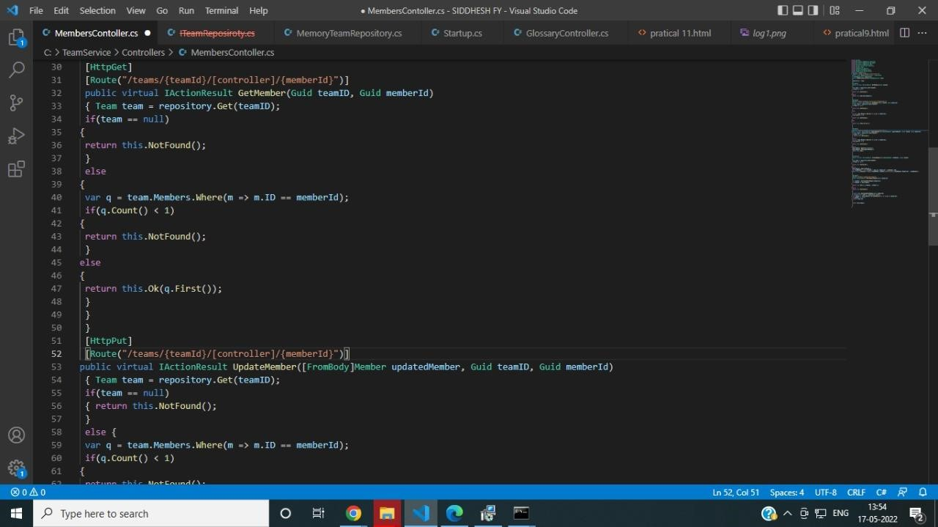

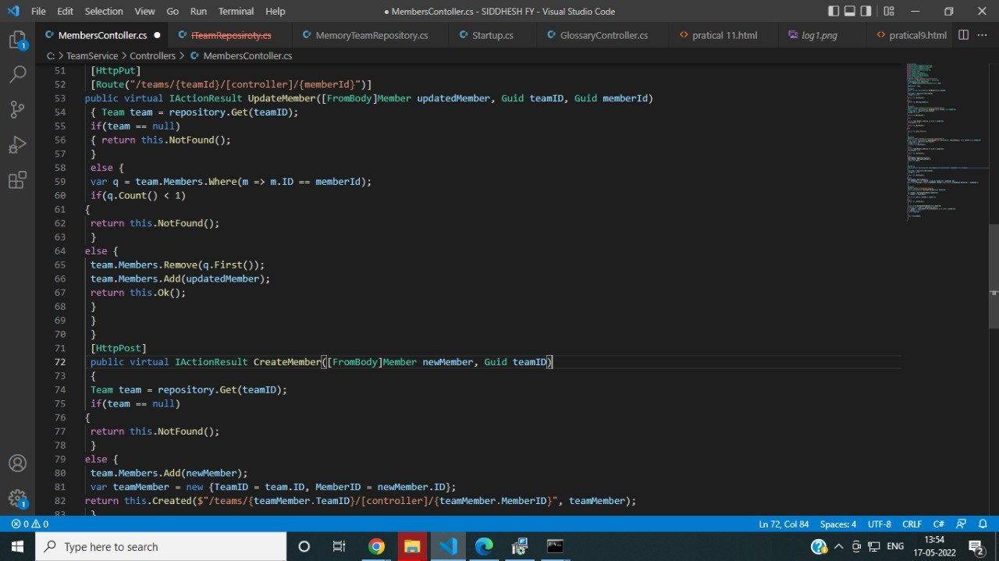

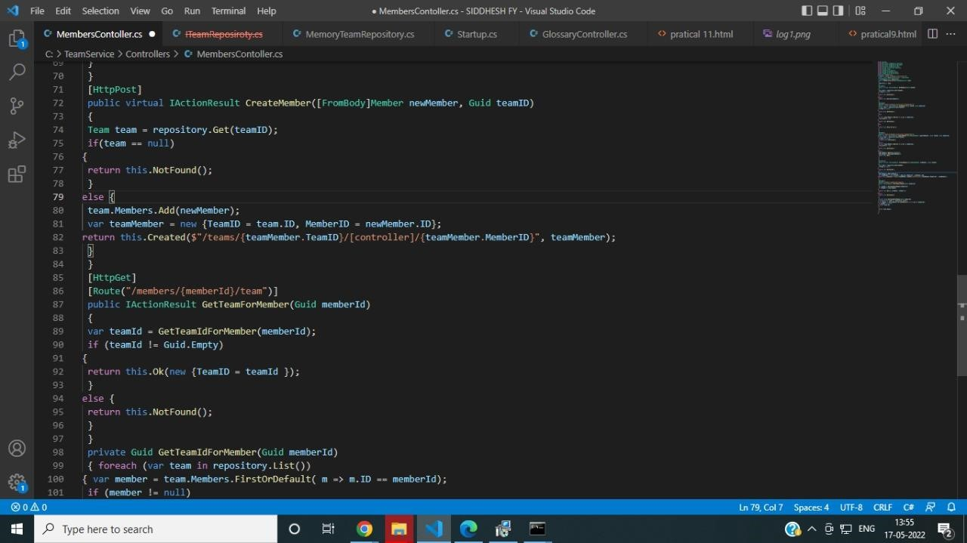

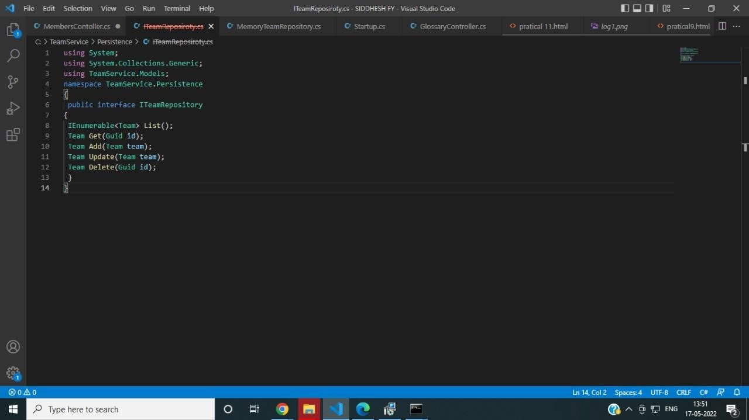

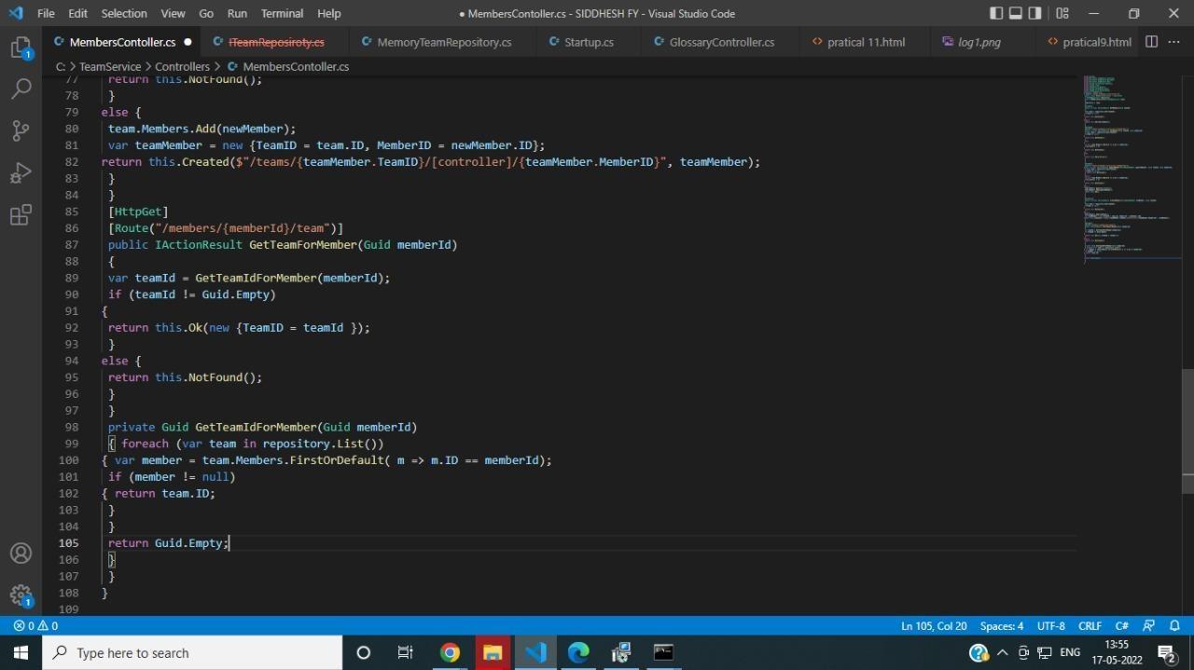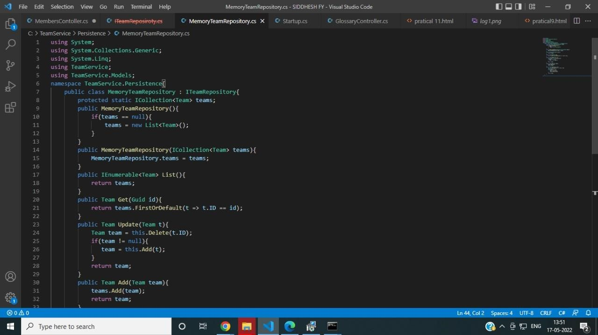

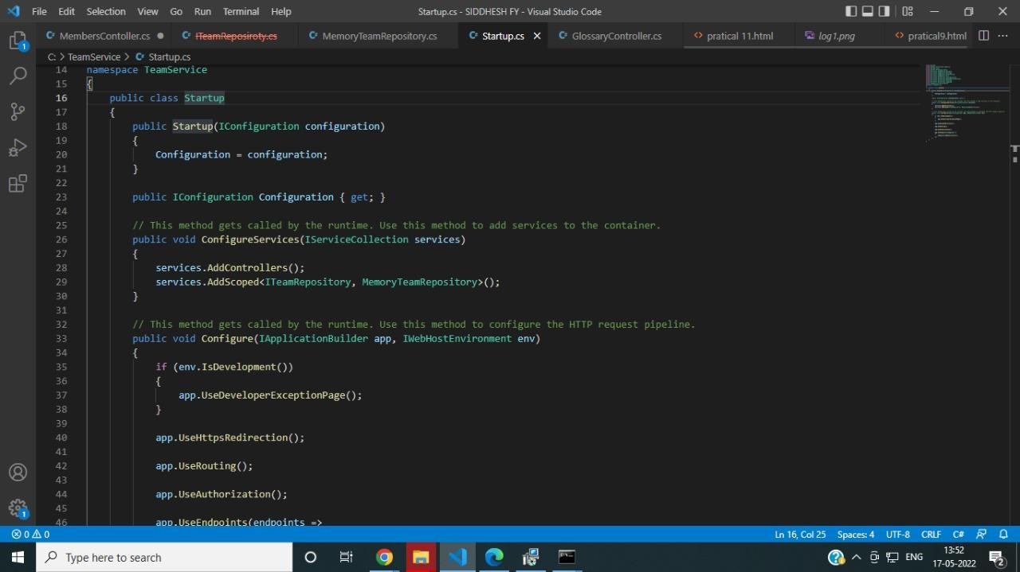

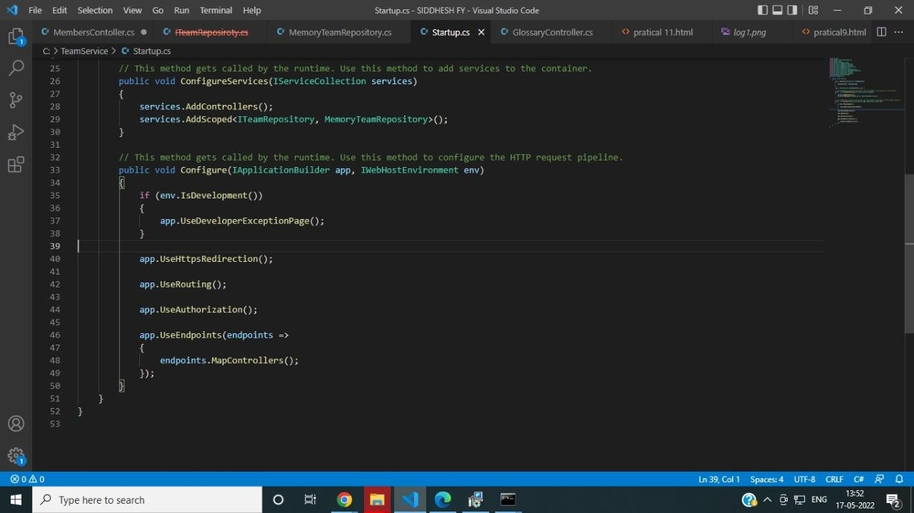

**Output: -**

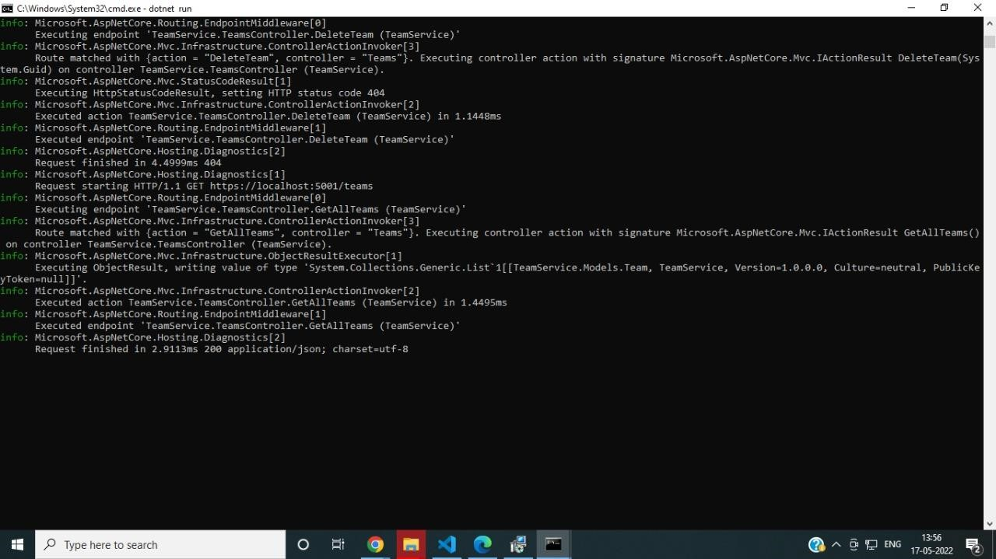



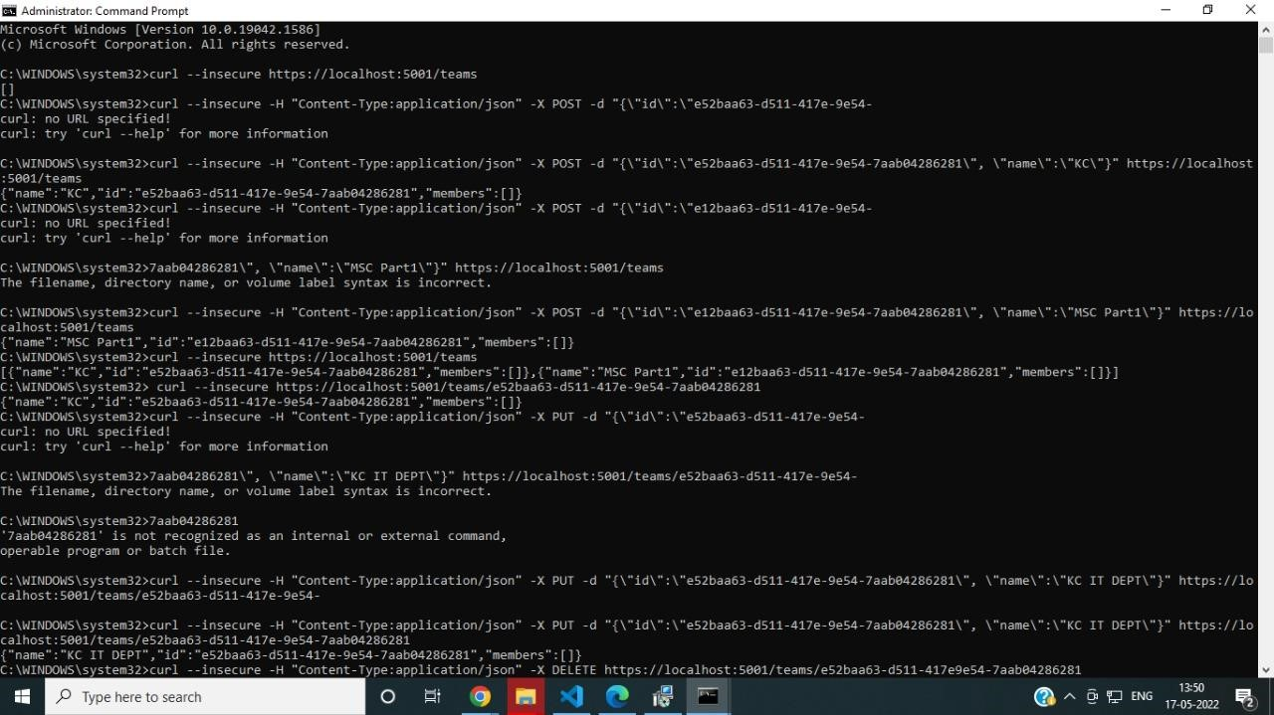

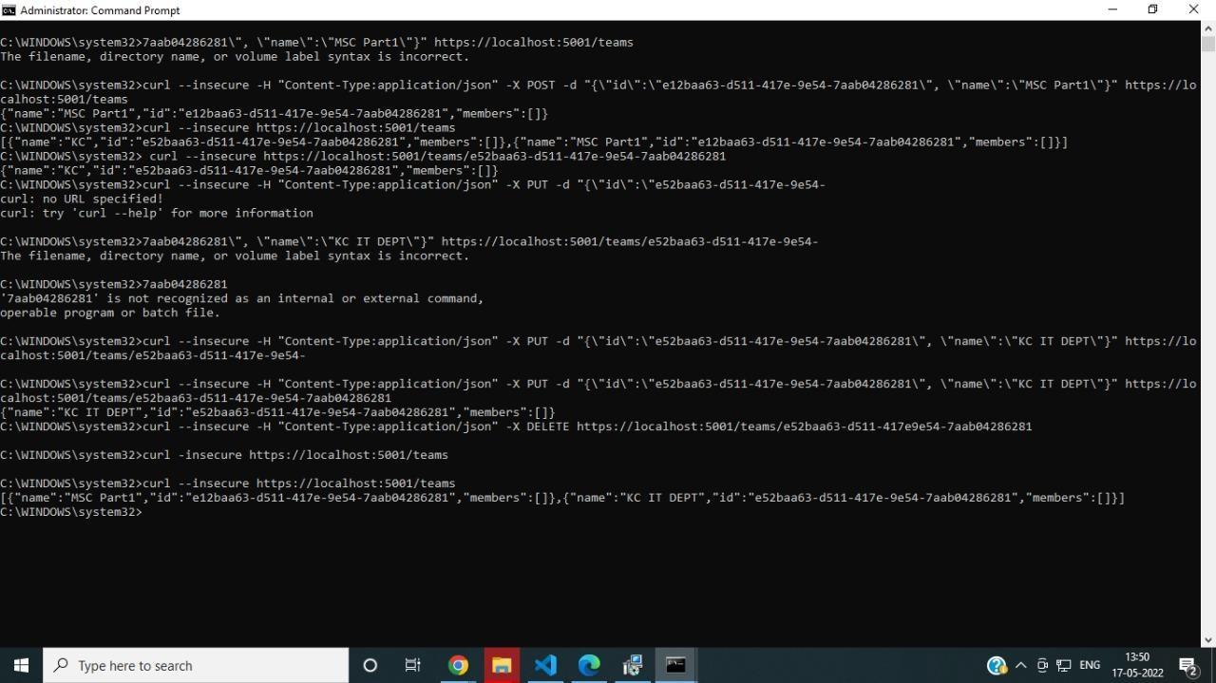

**Practical No: 7**

**Aim: -** Creating backing service with ASP .net core

**Code implementation: (Include steps)**

**Command : To run teamservice** docker run -d -p 5000:5000 -e PORT=5000 \ -e LOCATION__URL=http://localhost:5001 \ dotnetcoreservices/teamservice:location **Command: to run location service**  docker run -d -p 5001:5001 -e PORT=5001 \ dotnetcoreservices/locationservice:nodb **Command : to check running images in docker**  docker images

**Command: to create new team**  curl -H "Content-Type:application/json" -X POST -d \

'{"id":"e52baa63-d511-417e-9e54-7aab04286281", "name":"KC"}' <http://localhost:5000/teams>**Command :To confirm that team is added** curl <http://localhost:5000/teams/e52baa63-d511-417e-9e54-7aab04286281>**Command : to add new member to team** curl -H "Content-Type:application/json" -X POST -d \

'{"id":"63e7acf8-8fae-42ce-9349-3c8593ac8292", "firstName":"Kirti", "lastName":"Bhatt"}' <http://localhost:5000/teams/e52baa63-d511-417e-9e54-7aab04286281/members>curl http://localhost:5000/teams/e52baa63-d511-417e-9e54-7aab04286281

**Output:**

